

Ford Customer Service Division

F C S D

Network Locations (PDC)

Supplier Handbook

FCSD working together with Global Supply Chain to improve processes, technology, and material flow management to meet the needs of a changing market place.

This Book is Available at Ford Customer Service Division (FCSD) Supplier Requirements resource [https://web.pslsupp.ford.com]

*The links in this document will only work in the MS Word Version. In the PDF file, the links are deactivated.*

Network Locations (PDC) Table Of Contents

- First Steps 8
  - Register for Covisint 8
  - Request Ford Supplier Portal Access 8
  - Establish an EDI Mailbox 8
  - Obtain a RACF ID 8
  - 3270 Sub-Package Access 8
  - Attend DDL Training 8
  - Service Packaging Access/IMS3 8
  - Setup Transportation 8
  - SIM (Supplier Improvement Metrics) Sub-Package Access 8
- RACF ID 9
  - New RACF ID Request 9
  - Existing RACF ID Request 9
  - Accessing the RACF ID Request Form 9
  - Password Expiration and Revocation 9
  - How to Reset Revoked Passwords 9
- Helpdesks & FCSD Contact Information 9
  - GEC Hub/GSEC 9
  - SPOC (Single Point Of Contact) 9
  - Support Outside of Europe 10
  - EDI Coordinator 10
  - CBS & WERS Helpdesks 10
  - SDA (Supplier Delivery Analyst) Contact 10
  - FCSD FPoC (First Point of Contact) 10
  - Contact List (CLSA) 10
  - NAP (North American Payables) 11
- Purchasing Information 11
  - Purchasing Website 11
  - Purchasing Contact 11
  - Global Terms & Conditions 11
- PIMS (Purchasing Information Management System) 11
  - Contacting PIMS Helpdesk 11
- Ford Field Accounting (Bill To) & FCSD Dummy Code 12
  - Ford Field Accounting Department (B82AA) 12
  - Ford Customer Service Division (AF52M) 12
  - EFT (Electronic Funds Transfer) 12
- North America & Mexico DDL Training Class 12
  - DDL Indicator in Supplier Location Profile (SPJA) 12
  - Online Training 12
  - DDL Manual 12
  - North America DDL Training Classes 13
  - Mexico DDL Training Classes 13
- European DDL Training Class 13
  - United Kingdom DDL Training Classes 13
- Asia Pacific & Africa DDL Training 13
  - Asia Pacific & Africa DDL Training Class 13
- Packaging Requirements 14
  - FCSD Packaging Contact 14
  - Service Packaging Access/IMS3 14
- SIM (Supplier Improvement Metrics) Access 14
  - SIM Weekly Delivery Detail Refresh 14
  - SIM Monthly Refresh Launch Schedule 14
  - Request SIM Sub-Package 14
  - Accessing SIM 14
  - Register for SIM Access 14
  - Access Problems 14
  - Tokens/Password Issues 15
- Supplier Customer Service Contacts 15
- New Model Part Availability 15
  - Response Time 15
  - Notification 15
  - Major Launches 15
- Supplier Follow-Up (SOSA) Screen/Work Queue 15
- Carrier Compliance 15
  - Compliance Form Location 15
- Supplier Compliance 15
  - Supplier Compliance Contact 15
  - SLI Number Requirement 15
  - Accurate Trailer Number 16
  - Expectations of Suppliers 16
  - Implementation and Use of SUMIT/CVN 16
  - Supplier Non-Compliance 16
  - Non-Compliant Conditions 16
- Schneider Logistics, Inc. (SLI) (North America) 16
  - Schneider Logistics Inc. 16
  - Mixed Pallets 17
  - 3rd Party Billing Address (Freight Payment) 17
- Exel/DHL Logistics (Outside Europe) 17
  - Exel Contact Information 17
  - Exel Welcome Packet 17
  - Collection Note/Scheduling Pickup 17
- Online PO System (a.k.a. Tri-Annual Report) 18
  - Full Purchase Order 18
  - Weekly Amendments 18
  - Password 18
  - Accessing The PO System 18
- Releasing Process 19
  - DRP (Distribution Requirements Planning) 19
  - Release Availability 19
  - Release Issuing 19
  - Volume Group 19
- EDI (Electronic Data Interchange) Mailbox & Connectivity 20
  - EDI & Connectivity FAQ's 20
  - EDI SPECS (ANSI X12 & EDIFACT) 20
  - EDI Manual (ANSI X12) 20
  - EDI Formats 20
  - EDI Business Processes 20
  - Establishing a Mailbox & Connectivity 20
  - Migration 20
  - Hardware/Software Upgrades 20
  - ANX (Advanced Network Exchange) Connectivity 20
  - VAN (Value Added Network) Provider 20
  - Ford Approved VAN Providers 21
  - 3rd Party EDI/Service Bureau 21
  - 3rd Party/Service Bureau EDI Providers 21
  - WebEDI/WAM (Web Access Module) 21
  - WebEDI/WAM Recommendations 21
  - Translation Software 21
  - EDI Connection Request 21
  - Access to WebEDI/WAM 22
  - EDI ANSI X12 Transactions 22
  - EDIFACT Transactions 22
- GEC Hub Re-Queue Process 22
  - Suppliers Utilizing a VAN 22
  - Suppliers Utilizing Direct ANX 22
  - Requeue Request 22
  - Required Criteria 22
  - Re-Queued Data 23
  - VAN Responsibility 23
- Order Processing 23
  - Ship Standards 23
  - Ship Schedule 23
  - Ship Week 23
- ANSI 830 Material Release Validations 23
  - Service Part Number Validation 23
  - Part Number Discrepancy 23
  - Updating Supplier Records 23
  - Service Number/Supplier Location Validation 23
  - Movement of Tooling 23
  - Service Part Number/Supplier Location/Ship To Validation 23
  - Multiple Receiving Locations 23
  - Examples of Multiple Ship To 24
  - Service Part Number/Supplier Validation 24
  - Intermediate Consignees (Packagers) 24
  - Intermediate Consignee Change Notification 24
  - Hard Coding 24
  - CUM Tracking 24
  - CUM (Cumulative) Quantity Validation 24
  - CUM Reconciliation 24
  - CUM Location 24
  - CUM Correction 24
  - CUM Reset/Rollback 24
  - Determining Ship Quantity 25
  - Requirements Determination 25
  - Forecast Schedules 25
  - Monthly Bucket Dates 25
  - Firm & Planning CUMS 25
  - Authorization Period 25
  - Component Procurement 25
- ANSI 856 ASN (Advance Ship Notice) 25
  - Current CUM Quantity 25
  - Subsequent Order 25
  - Mirror 830 Material Release 25
  - ASN Transmittal 26
  - Original ASN 26
  - ASN Cancellation 26
  - ASN Correction/Replacement 26
  - ASN Correction Timing 26
  - Time Zone 26
- 856 Emergency Order Dealer Direct ASN 26
  - Ship To 26
  - Material Release 26
  - No Intermediate Consignee 26
  - Decrementing CUM on Release 26
  - Supplier Payment 26
  - Inaccurate ASN 26
  - ASN Correction 27
  - Dealer Code/DOR Number 27
  - Submit Invoice 27
  - Ancillary Charges Remit To 27
  - FPoC (First Point of Contact) 27
- DSO (Domestic Special Order) Emergency Order Shipments 27
  - Ship To 27
  - Material Release 27
  - Analyst Codes 27
- ASN Purge Rules 28
- 997 Functional Acknowledgement 28
  - Verification 28
  - Accepted/Rejected 28
  - Resending Corrected ASN 28
  - 997 Reconciliation 28
  - 997 Help 28
- 861 Receipt Advise 29
  - Acknowledgement 29
  - Quantity Received 29
  - Quantity in Question 29
  - Resolving Discrepancies 29
- EDIFACT 29
  - DELFOR (Delivery Schedule Message) 29
  - DESADV (Dispatch Advice Message) 29
  - CIA (Common Internal Acknowledgement) 29
- CMMS/IMS7 Production Plants Shipping to FCSD 29
  - CMMS Helpdesks 29
  - CMMS Training 29
  - CMMS Carrier Code Errors 29
  - Reference Part Number 30
  - Reference Part Maintenance 30
  - Validation Rules 30
  - Customer Profile (AAHA) 30
  - Dealer Direct ASN in CMMS 31
  - CMMS System Won't Allow Shipper 32
  - Production Plants Service/Engineering # 33
  - Firm Requirements 33
- MMOG/LE (Materials Management Operations Guideline/Logistics Evaluation) 34
  - What is MMOG? 34
  - AIAG (Automotive Industry Action Group) 34
  - Accessing MMOG Instructions 34
  - Assessment Criteria 34
  - Management Responsibility 34
  - Self Assessment 35
- Q1 Delivery Performance 35
  - QC (Quality Control) 35
  - Q1 Rating Measurements 35
- SIM PDC Dispute 35
  - Weekly Delivery Details 35
  - On-Line Dispute Manual 35
  - Disputing Point Loss 35
  - Dispute Not Available 35
  - DDL System not Accessible 35
  - Conformances 35
  - Non-Disputable Issues 36
- Dispute Analysts 36
- Conformances 36
  - Supplier Service Part Remarks (RESA) 36
- Timeliness (EDICM) 36
  - ASN Journal (AJAA) 36
  - Penalization 36
- Accuracy (NOASN) 36
  - Transaction Register (TABA) 36
  - Unable To View 67 Transaction 36
  - ASN Journal (AJAA) 36
  - Penalization 37
- Early/Overshipments 37
  - Penalization 37
- DDL Non-Compliance 37
- Promise Accuracy 37
- Shipping Discrepancies (INQTY) 37
  - Transaction Register (TABA) 37
  - Provide Remarks 37
  - Penalization 37
- NOT (Not-On-Time) 37
  - Reviewing 37
  - Check ASN Journal (AJAA) 37
  - Supplier Service Part Remarks (RESA) 37
  - Dispute 37
  - Carrier Compliance Form 37
- CUM Imbalance (CMBAL) 38
  - Conformance Disputed 38
  - Review 38
  - ASN Journal (AJAA) 38
  - CUM Disagreement 38
- Past Due 38
  - Review 38
  - ASN Not Showing 38
  - Document 38
  - Dispute 38
- Emergency Order Responsiveness 38
- FCSD Intermediate Consignees (Contract Packagers) 39
- FCSD Network Locations/PDC (Part Distribution Centers) 40
- Covisint 41
  - Identifying your CSA 41
  - Covisint Helpdesk 41
  - Assigning A New CSA 41
  - Covisint Knowledge Base (FAQ) 41
- Covisint Registration 42
  - Web Link 42
  - Find Organization 42
  - Search Results 43
  - Complete Form 43
  - User Information 44
  - Applications 44
  - Location Code 45
  - Company CSA 45
- Adding Ford Supplier Portal 46
- Accessing DDL (Direct Data Link) 46
  - Covisint 46
  - Click on Ford Supplier Portal 47
  - Click On Applications 47
  - Click On 3270 Access 48
  - Click "Run 3270 Application 48
  - Security Warning 49
  - Pop-Up Blocker 49
  - WebConnect Client 49
  - WebConnect Launched 49
  - User ID and Password 50
  - FCSD Corporate Applications 50
  - Supplier Follow-Up (SOSA) 51
  - Populating Supplier Follow-Up (SOSA) 51
  - All Categories 52
- DDL/IMS2 Supplier Screens 53
- Revisions 54

- Network Location (PDC) Business Requirements

The following Supplier PDC Ship requirements have been established to achieve optimum customer satisfaction. This document can be downloaded from Ford Customer Service Division (FCSD) Supplier Requirements resource [https://web.pslsupp.ford.com].

- First Steps
The following are the first steps when you have been notified that you have become
a new Service supplier.

- Register for Covisint
- Request Ford Supplier Portal
- Establish an EDI Mailbox
- Obtain A RACF ID
- Request 3270 Sub-Package
- Attend DDL Training
- Request access to IMS3 Packaging
- Setup Transportation
- Request SIM Sub-Package

  - Register for Covisint
You will need to register for Covisint (Refer to 51.0) to access any internal Ford Systems and Websites. If you currently ship to Production under the same Supplier GSDB Code, you do not need to register separately for Service.

  - Request Ford Supplier Portal Access
Ford Supplier Portal allows you to access the IMS2/DDL System and Websites. Once you have obtained your Covisint ID, you will need to request access to the Ford Supplier Portal (Refer to 52.0).

  - Establish an EDI Mailbox
All suppliers must be EDI Complaint. For Suppliers utilizing ANSI X12 or EDIFACT (Refer to 21.0)

  - Obtain A RACF ID
Request a new RACF ID (Refer to 2.1) or Request a service link for your Production RACF ID (Refer to 2.2). This applies to ALL suppliers shipping to North America.

  - 3270 Sub-Package Access
The 3270 Application is the IMS2/DDL System. DDL is designed to provide an effective, efficient communication link between the supply base and FCSD. Access is obtained through the Covisint Portal. You will need to request access to the 3270 just as you did Ford Supplier Portal.

- Log into Covisint
- Click on Ford Supplier Portal
- Click on Applications
- Find the 3270 application
- Click on the Pencil
- Click Request button
- Complete the Reason for Request

  - Attend DDL Training
Suppliers Must obtain a RACF ID (Refer to 2.0) PRIOR to DDL Training (Refer to 7.0) whether you attend online or in person.

  - Service Packaging Access/IMS3
Once a RACF ID has been obtained, you must then obtain access to the Packaging Specification Database within IMS3. (Refer to 10.2)

  - Setup Transportation
North American suppliers will contact SLI (Schneider Logistics) (Refer to 17.0).
Overseas suppliers should receive a Welcome Packet from Exel (outside Europe). If you have not received one, please contact Exel (Refer to 18.0).

  - SIM (Supplier Improvement Metrics) Sub-Package Access
You will need to request this Sub-Package in Covisint. (Refer to 11.3)
- RACF ID
A RACF ID (User ID) is required within 10 days of receiving a GSDB Code. You will need to have access to Covisint and Ford Supplier Portal to request a RACF ID. RACF ID's are not to be shared by employees. (Return to 1.6)

  - New RACF ID Request
If you do not have a RACF ID for either Production or Service, you will need to submit the new request form for IMS2 Service DDL ONLY. (Return to 1.4)

  - Existing RACF ID Request
If a supplier is currently shipping to Production and has a Production RACF ID (begins with AA) to access the IMS7/CMMS System, the same RACF ID can be used for Service. You will need to add access and route to IMS2 ONLY. (Return to 1.4)

  - Accessing the RACF ID Request Form (Return to 53.10)

- Log into Covisint
- Click on Ford Supplier Portal
- Click on Applications
- Click on the link MP&L 6 B2B Home Page
- Click on the link RACFID Requests - DDL(IMS7), MMP(IMS2), Packaging Service (IMS3)
- Request Type; Choose:
  - Add Access - If you have a existing RACF ID
  - New Request - If an existing RACF ID does not exist
  - CSA Request - If you are requesting a CSA ID
- How would you like to route this request? Choose:
  - IMS2 - MMP and/or IMS3 - Packaging Service Only (for SERVICE access ONLY)*

* Due to intermittent interruptions in receiving the request form, please send a copy of the conformation received or a screen-print of the "This is what you just submitted" screen via email to SRVCDDL@Ford.com.

  - Password Expiration and Revocation
Supplier's DDL/IMS2 Password will be expired or revoked under the following conditions:

- By the user not changing their password every 45 days
- By the user not utilizing the system in 90 days
- By the user typing an incorrect password three (3) consecutive times

  - How to Reset Revoked Passwords
If you receive the error message "User ID Revoked" when trying to log into the IMS2/DDL System, it is your password, not your RACF ID that has been revoked. Your CSA can reset your password. CSA's requiring assistance for password resets should contact srvcddl@ford.com.

- Helpdesks & FCSD Contact Information

Important contact information.

  - GEC Hub/GSEC
Suppliers are responsible to contact the GEC (Global Electronic Commerce) Hub/GSEC (Global Supplier Electronic Commerce) to set up a supplier mailbox and conduct connectivity testing (Refer to 21.6).

GEC Hub/GSEC Website | Covisint/Ford Supplier Portal Link
https://web.gsec.ford.com | Global Supplier Electronic Commerce - Business

  - SPoC (Single Point of Contact)
The Ford SPoC Helpdesk phone numbers. (Return to 3.4) (Return to 29.5)

Helpdesk | Toll Free | Direct Dial
SPoC | (888) 317-4957 | (313) 317-4957
GEC Hub/GSEC | (888) 317-4957 | (313) 317-4957
When calling, ask for your ticket to be routed to the GEC Hub EDI Helpdesk.

Support Outside of Europe
Support Centers outside of Europe.

Support Center | Internal | External
Brazil | 8400 | +55 (11) 4174 8400
Australia | 8686 | +61 (3) 9359 8686

  - EDI Coordinators
You can contact the FCSD EDI or FoC EDI Coordinators for EDI/ASN issues if you have received an (A)ccepted 997. If you received a (R)ejected 997, please contact your internal EDI/IT Department and/or SPoC (Refer to 3.2) prior to contacting the EDI Coordinator. (Return to 21.8) (Return to 26.11)

Helpdesk | Email
FCSD EDI Coordinator | FCSDEDI@Ford.com
FoC (Ford of Canada) EDI Coordinator | FoCEDI@Ford.com

  - CBS & WERS Helpdesks
CBS (Central Billing System) & WERS (Worldwide Engineering Release System) Helpdesks.

Helpdesk | Email
CBS (Central Billing System) | CBSHELP@Ford.com
WERS (Worldwide Engineering Release System) | HWERS@Ford.com

  - SDA (Supplier Delivery Analyst) Contact
You can find the contact information for your SDA (Supplier Delivery Analyst) and the Supplier Compliance contact by clicking the FORD - DELIVERY ANALYST (Service) link on the SIM Website. (Refer to 11.4)

Name | Title | Parent Codes | Contact
Mark Trombetta | Supplier Perform Mgr | N/A | MTrombet@Ford.com
Heather Evison | SDA | (A-B), (E-K) | (313) 390-4536 | HRatclif@Ford.com
Debbie Walker | SDA | (AB6R, FM00, H8EE, TC12, T525) (D), (S-V) | (313) 390-4237 | DWalker3@Ford.com
Sandy Poulos | SDA | (3400), (C), (L-R), (W-Z) | (313) 390-4118 | SPoulos@Ford.com
Teresa Echols | Shipping Compliance | PDC Suppliers ONLY | SupplierCompliance@Schneider.com

  - FCSD FPoC (First Point of Contact)
The main contact for FCSD questions is your Supply Chain/Releasing Analyst. You can locate your analyst in the following ways:

- In the PER*EX Segment of the 830 Material Release
- On the Contact List (CLSA) Screen in DDL (NDA-NAAO Demand Analyst)
- On the Global Part information (GPMA) Screen in DDL listed as the Demand Analyst (Part Specific)

  - Contact List (CLSA)
The Contact List (CLSA) screen in IMS2/DDL is used to find contact information for both the Supplier and Ford.

- Enter “S” in CONTACT TYPE to display Supplier Contacts.
- Enter “F” in CONTACT TYPE to display Ford Contacts.
- Enter "CNTRL" in the RECEIVING LOC field and leave CONTACT TYPE blank to display more contacts.
- Enter the receiving location (packager/depot) in the RECEIVING LOC field and leave the CONTACT TYPE blank to display receiving location contacts.

  - NAP (North American Payables)
For any accounting questions or issues, please contact North American Payables.

Helpdesk | Email
Customer Service | NAPCUST@Ford.com
Check Audit | NAPCHKAD@Ford.com
Debit Balances | NAPDBAL1@Ford.com
Helpdesk | NAPHELP@Ford.com
Disbursements | NAPDISB@Ford.com
Wire Transfer | NAPWIRET@Ford.com
EPAY | NAPEPAY@Ford.com
Payment Terms* | NAPTERM@Ford.com
*Supplier must specify the division: "F" for Service; "A" for Production

- Purchasing Information

  - Purchasing Website
You can access the purchasing website via Covisint.

- Log into Covisint
- Click on Ford Supplier Portal
- Click on Applications
- Click on the link Ford Customer Service Division (FCSD) Purchasing

  - Purchasing Contact
You can locate your FCSD Buyer by part number level on Global Part Information (GPMA) or Contact List (CLSA) in IMS2/DDL.

  - Global Terms & Conditions
You can access the Global Terms & Conditions on the purchasing website.

- Log into Covisint
- Click on Ford Supplier Portal
- Click on Applications
- Click on the link Ford Customer Service Division (FCSD) Purchasing
- Click on Global Terms & Conditions

- PIMS (Purchasing Information Management System)
The PIMS helpdesk handles primarily NA supplier issues for select Purchasing applications such as:

- GSDB Online - Updating Supplier Name, Address, Remit-To, Banking or EFT
- e-Payables - Payment and Invoice information
- Web Quotes - PO, RFQ, and Tooling
- Approve and assist the suppliers in setting up Ford Supplier Portal in Covisint.

Helpdesk | Email
PIMS (Purchasing Management System) | SUPLHELP@Ford.com

  - Contacting PIMS Helpdesk
When contacting PIMS, please include the following information in your email.

  - Description of your issue including the system, if applicable.
  - Contact information, including their name, phone number, and email address.
  - The GSDB (Supplier) Site Code you are using or trying to use.
  - Your Company's Name.
  - Your Covisint ID (if your issue is related to Covisint/ Ford Supplier Portal access or application access).

- Ford Field Accounting (Bill To) & FCSD Dummy Code
Ford Field Accounting Department Bill To & FCSD Physical Addresses (NO paper invoices accepted). You must setup EFT via Covisint.

  - Ford Field Accounting Department (B82AA)
We do not accept paper invoices, please do not mail invoices to this address.

B82AA - Ford Field Accounting Department (Bill To)
Ford Field Accounting Department
16800 Executive Plaza Drive
Dearborn, Michigan 48126-4207

  - Ford Customer Service Division (AF52M)
This is not a physical ship to location. This code is only used for CUM management purposes.

AF52M - Ford Customer Service Division
Ford Customer Service Division
16800 Executive Plaza Drive
Dearborn, Michigan 48126-4207

  - EFT (Electronic Funds Transfer)
Follow these directions to sign up for Electronic Funds Transfer. The EPAY service package application will need to be requested.

- Log onto Covisint
- Click on Ford Supplier Portal
- Click on the Applications
- Scroll down to e-Payables (EPAY) & e-Payables (EPAY)/North America
- Click on the Pencil
- Click the Request button
- Complete the Reason for Request; Submit

- North America & Mexico DDL Training Class
Suppliers are required to schedule and attend DDL Training by contacting the training facilities listed below. NOTE: SUPPLIER MUST OBTAIN A RACF ID PRIOR TO CLASS. (Return to 1.6)

  - DDL Indicator in Supplier Location Profile (SPJA)
'T' indicates supplier is in "Training Mode" for the balance of the current month and the entire following month. The system will automatically Launch (L) the supplier after the training period has ended. Once the Indicator turns to (L), the supplier is accountable for working DDL. Non-compliance to DDL requirements will impact SDPR.

  - Online Training
Online Training is available on the North American Supply Chain website. You will need a Covisint ID and access to Ford Supplier Portal to access this site.

- Log into Covisint
- Click on Ford Supplier Portal
- Click on Applications
- Click on the link Ford Customer Service Division (FCSD) Supplier Requirements Resource
- Click on the Yellow DDL Online Training Button

  - DDL Manual
Suppliers can find the DDL Manual by chapter in Word or PDF format on the North American Supply Chain website via Covisint. (Return to 14.0)

- Log into Covisint
- Click on Ford Supplier Portal
- Click on Applications
- Click on the link Ford Customer Service Division (FCSD) Supplier Requirements Resource
- Click on the Yellow DDL Manual - English Button or Scroll to the bottom of the web page

  - North America DDL Training Classes

North American Training and Development Center
Course Name | DDL FOR FORD CUSTOMER SERVICE DIVISION - FCSD
Toll-Free | (888) 993-3673
Direct | (313) 845-5255
Course Number/Code | 3207
Length & Time | 16 Hours (2 Days)
Website | https://web.fsli.ford.com

  - Mexico DDL Training Classes

Ford Supplier Learning Institute Mexico
Course Name | DIRECT DATA LINK MMP-IMS2
Contact | Perla Álvarez del Castillo
Email | PAlvarez@FSLIM.com.mx
Direct | +01 (52) 461-613-2616
Course Number/Code | 3040
Length & Time | 8 Hours
Website | www.fslim.com.mx

- European DDL Training Class

  - United Kingdom DDL Training Classes
The UK does not run open classes for this training, they base it according to demand. They can run it as a WebEx course, split into two sessions of approximately half a day each. Materials are sent electronically along with pre-training communication with the participants to ensure that the system access set-ups are all working.

United Kingdom DDL Training Classes
Course Name | Material Management Process - MMP/IMS2 (DDL for FCSD North America)
Contact | Vivian Giddings
Email | VGiddin1@Ford.com
Direct | +44-126-840-2868
Length & Time | 8 Hours
Website | http://www.tmaonline.ford.com

- Asia Pacific & Africa DDL Training

  - Asia Pacific & Africa DDL Training Class
Suppliers in the APA region who want to take FCSD DDL Training may send their request to the generic email below. After receiving the request, they will review and contact the supplier and arrange an on-site or WebEx training.

Asia Pacific & Africa DDL Training Class
Course Name | DDL for FCSD North America
Email | SAPA@Ford.com

- Packaging Requirements
To ensure shipments conform to FCSD packaging standards, packaging specifications can be accessed at the Packaging Website via the Covisint Portal.

- Log into Covisint
- Click on Ford Supplier Portal
- Click on Applications
- Click on the link Ford Customer Service Division (FCSD) Packaging

  - FCSD Packaging Contact
For questions about Packaging or Packaging Specs, please contact the FCSD Packaging department.

Helpdesk | Phone | Email
FCSD Packaging | 1-(888) FCSDPKG  (327-3754) | FCSDPKG@Creativedatainc.com

  - Service Packaging Access/IMS3
Once you have a RACF ID for Service, you will need access to the Packaging Specification Database within IMS3. All New Requests, New Passwords, and/or Password Resets will go to Creative Data Inc. (Return to 1.7)

Service Packaging Access/IMS3
Creative Data Inc. | PASSWORDRESET@CreativeDataInc.com
Include in your email | - Name (First & Last)  - Department  - Supplier Name  - RACF ID  - Password you want to use

- SIM (Supplier Improvement Metrics) Access
A Tool used to monitor a suppliers performance. Suppliers are required to Dispute on-line from the 'Weekly Delivery Details' in SIM.(Refer to 35.0)

  - SIM Weekly Delivery Detail Refresh
Weekly Delivery Details are refreshed and available to review every Tuesday after 7:00 AM EST.

  - SIM Monthly Refresh Launch Schedule
You can access the Monthly Refresh Launch Schedule in SIM from the Supplier Improvements Metrics - Summary screen under the SIM Refresh Launch Schedule link.

  - Request SIM Sub-Package (Return to 1.9)

- Log into Covisint
- Click on Ford Supplier Portal
- Click on Applications
- Scroll to Supplier Improvement Metrics (SIM) - Ford
- Click on the Pencil
- Click the Request button
- Complete the Reason for Request; Submit

  - Accessing SIM
Suppliers access SIM through the Covisint Portal. (Return to 3.6)

- Log into Covisint
- Click on Ford Supplier Portal
- Click on Applications
- Click on the link Supplier Improvement Metrics (SIM) - Ford

  - Register for SIM Access
Contact your CSA (Corporate Security Administrator) to request access.

  - Access Problems
If there are any problems gaining access to SIM, go to https://web.fsp.ford.com/support.html.

  - Tokens/Password Issues

Suppliers should go to https://web.fsp.ford.com/support.html.

- Supplier Customer Service Contacts

Supplier needs to update the contacts for the following positions on the Contact List (CLSA) in DDL.

- Customer Service
- Engineering
- Sales
- New Model Coordinator
- Quality Control
- Accounting
- EDI

- New Model Part Availability
New Model Parts are launched into the system approximately six (6) months in advance of Job #1. FCSD's objective is to have 100% part availability by the established program Job #1/OK-To-Ship/Pre-Sell Date (date vehicles are approved to leave the assembly plants).

  - Response Time
Supplier shall establish a business process to support a maximum seven (7) day response time objective for New Model part availability requests.

  - Notification
New Model requests will appear on the suppliers Supplier Follow-Up (SOSA) under Group 3 in DDL for part availability.

  - Major Launches
With major launches the 'All Supplier Letter' is provided to suppliers indicating when they are expected to ship.

- Supplier Follow-Up (SOSA)/Work Queue
The Supplier Follow-Up (SOSA) allows suppliers to review and work Conformances, gives notification of suspended ASN's, advises of New Model Parts, etc… Suppliers are required to access and utilize the Supplier Follow-Up (SOSA) Daily. Reference the DDL Manual. (Refer to 7.3)

- Carrier Compliance

The Carrier Compliance form must be completed for any carrier issues. (Return to 44.5)

  - Compliance Form Location

- Log onto Covisint
- Click Ford Supplier Portal
- Click Applications
- Click Ford Customer Service Division (FCSD) Supplier Requirements Resource
- Under Transportation Network Integrator
- Click North American Suppliers
- Click Carrier Performance and Compliance

- Supplier Compliance
Effective October 2009, FCSD began tracking and sending out End of Month (EOM) Supplier Shipping Compliance reports to suppliers who were found not in compliance with the Supplier Guidelines and Routing Instructions established by Ford Motor Company and Schneider Logistics.

  - Supplier Compliance Contact
Please direct all questions concerning Supplier Compliance or point-loss due to the Supplier Compliance program to:

- SupplierCompliance@Schneider.com

  - SLI Number Requirement
Suppliers are required to enter the SLI # in one (1) of the following segments of the ASN for all Truckload and Intermodal shipments that are scheduled through SLI (Schneider Logistics)

- REF*BM
- REF*CN

  - Accurate Trailer Number
FCSD will monitor compliance of trailer number accuracy in ASN's through the Shipping Compliance Program. Suppliers are required to enter an Accurate Trailer Number in the Conveyance Number field (TD303) of the ASN. Failure to comply will result in Supplier Non-Compliance (Refer to 16.6).

  - Expectations of Suppliers
Suppliers will adhere to the Supplier and Routing Instruction Guidelines

- Go to Ford Customer Service Division (FCSD) Purchasing
- Click on the "Service Parts Guide" link
- Then either "FCSD Packaging - North America" or "FCSD Service Parts Guide - North America".

  - Implementation and Use of SUMIT/CVN
All suppliers shipping to FCSD Network Locations (SDS-Supplier Direct Ship excluded) must fully utilize the Schneider SUMIT CVN™ tool for all shipments. SUMIT CVN is an internet application used to confirm accurate order quantities, communicate shipment information, and arrange all transportation for shipments to FCSD. To get setup on SUMIT CVN, please contact SLI. (Refer to 17.1)

  - Supplier Non-Compliance
If a supplier does not ship in accordance with the applicable Shipping Guidelines and/or Routing Instructions, including the above requirements the following actions will be taken: (Return to 16.3)

- Supplier Shipping Compliance reports will be sent to each supplier with non-compliant conditions identifying those issues.

- As repeat non-compliant conditions are identified, a letter will be sent to the supplier to advise that a Q1 point deduction will be generated. A five (5) point deduction will be applied on a monthly basis to each supplier that displays repeat non-compliant conditions.

- Regardless of the number of non-compliances within a given month, a five (5) point deduction will be made to the supplier's Q1 rating.

  - Non-Compliant Conditions
Suppliers can find a list of Non-Compliant Conditions and actions to prevent Non-Compliance on the North American Supply Chain Supplier Requirements Resource website.

- Log onto Covisint
- Click Ford Supplier Portal
- Click Applications
- Click Ford Customer Service Division (FCSD) Supplier Requirements Resource
- Under Transportation Network Integrator
- Click North American Suppliers
- Click Shipping Compliance

- Schneider Logistics, Inc. (SLI) (North America)

Logistics company contracted by FCSD to handle suppliers' outbound shipments. (Return to 1.8)

  - Schneider Logistics Inc.
Supplier must contact Schneider Logistics Inc. to establish routing guidelines prior to accessing Schneider's website. The SLI staff will coordinate requirements and shipments with the supplier. (Return to 16.5)

Location | Phone
US Suppliers | (800) 222-8403 Ext. 7010
Non-US Suppliers | (248) 848-5771
Laredo, TX Office | (956) 712-7087
Website | https://www.schneiderlogistics.com

  - Mixed Pallets
Suppliers are required to ship mixed pallets when the pallet is not filled by one (1) service part number. When pallets are mixed, suppliers must label as 'mixed pallet'.

  - 3rd Party Billing Address (Freight Payment)
All shipments should use the proper 3rd Party Billing on the Bill Of Lading (BOL). This should be on every shipment whether shipping TL, LTL, or FedEx. This address is for Freight Payment, in addition to, not a replacement for the BILL TO. This should be clearly indicated in the body of the Bill Of Lading (BOL). *THIS IS NOT A OPTIONAL REQUIREMENT*

3RD Party Billing Address (Freight Payment)
FCSD - Ford Customer Service Division
C/O Powertrack
P.O. Box 3001
Naperville, IL 60566-7001

- Exel/DHL Logistics (Outside Europe)
Logistics company that handles shipments for suppliers located outside of Europe, namely, Asia, South America, Africa, and Australia. (Return to 1.8)

  - Exel Contact Information

Department | Name | Phone | Email
E-Tracker, Air Freight requests, Air Freight Transit Detail | Sheri Manska | (734) 391-2867 | Sheri.Manska@Exel.com
ISF Management | James D. Collier | (734) 391-2756 | James.D.Collier@Exel.com
ISF Management Alternate | Renee Evans | (734) 391-2940 | Renee.Evans@Exel.com
Materials Manager | Ruben Maya | (734) 391-2791 | Ruben.Maya@US.Exel.com
Ocean Transportation Manager | April Bailey | (734) 391-2889 | April.Bailey@US.Exel.com
Materials Supervisor | Brenda Nisley | (734) 391-2837 | Brenda.Nisley@US.Exel.com
General Manager | Damon Richards | (734) 391-2041 | Damon.Richards@US.Exel.com
Group Email Address | FXC-SCMSEAEU@EXEL.COM

  - Exel Welcome Packet
You can find the Export Information/Welcome Packet on the North American Supply Chain Website.

- Log onto Covisint
- Click Ford Supplier Portal
- Click Applications
- Click Ford Customer Service Division (FCSD) Supplier Requirements Resource
- Click Transportation Network Integrator
- Click Non-North American Suppliers

  - Collection Note/Scheduling Pickup
The Collection Note (located in the Exel Welcome Packet), must be completed and emailed by 10:00 AM, 24-Hours prior to your fixed collection day.

- Online PO System (a.k.a. Tri-Annual Report)
In the past, the Tri-Annual Report was a hard copy of the Purchase Orders and Amendments that were sent to suppliers Three (3) times a year. Now the Purchase Order information is published both Weekly (Amendments) and Monthly (Full Purchase Order) and can be found online.

  - Full Purchase Order
The FULL purchase order is run on the First Saturday of each Month and posted to the web early the following week. The full run incorporates all of the weekly amendments since the prior month's full run. However, the prior month's amendments will remain available online, allowing you to go back and view as required.

  - Weekly Amendments
The weekly purchase order amendments are run every Friday and posted to the web early the following week.

  - Password
You will need a password to access the Online Purchase Order. You will have the option to create one when you enter the page. The PO system retrieves records based on the first four digits of the supplier code only.
*Passwords will be sent to your CSA within 24 hours. If your CSA doesn’t receive your password or if you have questions or issues with this website, please contact webinfo@brownart.com.

  - Accessing The PO System

- Log onto Covisint
- Click Ford Supplier Portal
- Click Applications
- Click Ford Customer Service Division (FCSD) Purchasing
- Click Purchase Order Information
- Click Purchase Order
- Enter Password; Submit

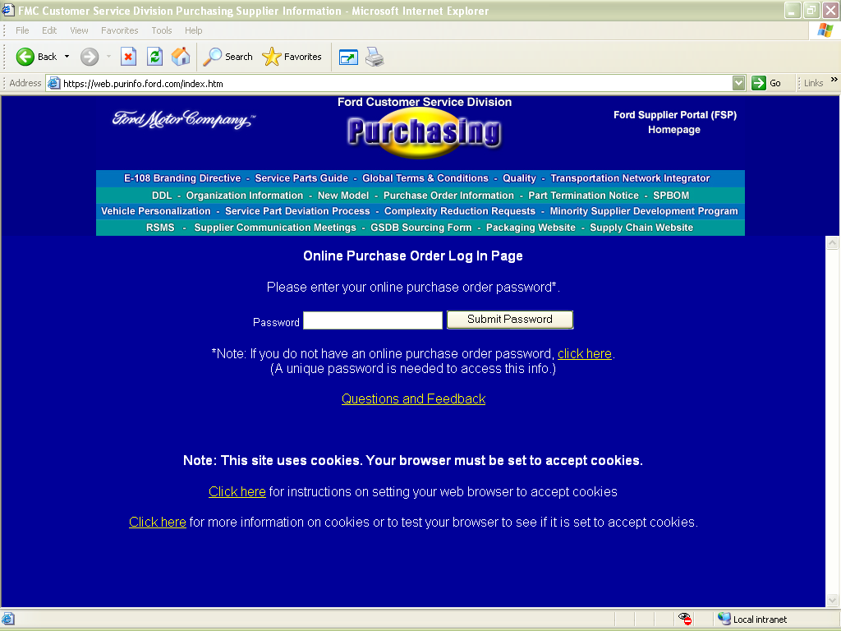
If you do not have a password. Click here to request one.
Enter your password here.

- Releasing Process
FCSD's Monthly Releasing Process Cycle will issue four (4) weekly material Releases throughout the month.

  - DRP (Distribution Requirements Planning)
The purpose of the DRP module is to determine recommended release quantities and timing. This automatic process calculates the requirements for each service part/network location for the next 104 weeks by calculating how the existing on-hand inventory will be depleted by the forecasted demand. DRP then makes recommendations on how to maintain the inventory plan based on the following. These recommendations are fed to the Releasing Module in the form of system order release quantities at lead-time.

- Forecast
- Existing Firm Releases
- Over-Pack Quantity
- Current Inventory Balances

  - Release Availability
EDI Material Releases will be available to suppliers every Saturday morning in your EDI Mailbox. In addition, Releases can be adjusted and created on a daily basis by the North America Supply Chain Analyst. New or revised Releases will be available in the EDI Mailbox Monday thru Thursday between 6:00-8:00 PM EST but can be viewed immediately in DDL. Suppliers must access their mailbox daily to ensure they are receiving all Material Releases.

  - Release Issuing
Releases are issued according to the Volume Group that a part is set in, therefore, you will not receive a release every week for every part you supply FCSD.

  - Volume Group
Volume Group is determined based on the EOQ (Economic Order Quantity) Model which determines the most economical way for Ford to buy inventory. It factors in ordering costs, carrying costs, and storage costs. The volume group reflects how much inventory we want to buy each time and the Releasing system issues releases in accordance to the volume groups in the table below. Although there are other exceptions that will trigger a part into releasing (ie: low point trigger, sourcing changes, etc), we are really unable to force a part to issue releases to a supplier outside of the parameters.

Volume Group | Buy Quantity | Release Issued | Meaning
A | Weekly | Weekly | A release will be issued weekly to buy a weeks worth of inventory
B | Bi-Weekly | Bi-Weekly | A release will be issued every 2 weeks for 2 weeks worth of inventory
C | Monthly | Monthly | A release will be issued every month for 1 months worth of inventory
D | 2 Months | Monthly | A release will be issued every month for 2 months worth of inventory
E | 3 Months | Monthly | A release will be issued every month for 3 months worth of inventory
F | 5 Months | Monthly | A release will be issued every month for 5 months worth of inventory
G | 8 Months | Monthly | A release will be issued every month for 8 months worth of inventory
H | 1 Year | Monthly | A release will be issued every month for 1 Year worth of inventory
I | 18 Months | Monthly | A release will be issued every month for 18 months worth of inventory
J | 2 Years | Monthly | A release will be issued every month for 2 Years worth of inventory

- EDI (Electronic Data Interchange) Mailbox & Connectivity
All suppliers must be EDI Complaint. Supplier shall complete successful programming and connectivity testing with the GEC Hub prior to program launch. In the event a supplier cannot transmit the required EDI transactions, supplier shall have in place a Third-Party EDI Service Provider. (Return to 1.3)

  - EDI & Connectivity FAQ's
For questions about connectivity, please refer to the FAQ section on the GSEC Website https://web.gsec.ford.com

  - EDI SPECS (ANSI X12 & EDIFACT)
Full EDI Specs can be found on the GSEC website under "Specs" located on the GSEC Website: https://web.gsec.ford.com/GEC/edispecs/edispecs.asp.

  - EDI Manual (ANSI X12)
The EDI Manual with layouts and explanations can be found on the North American Supply Chain
website

- Log onto Covisint
- Click Ford Supplier Portal
- Click Applications
- Click Ford Customer Service Division (FCSD) Supplier Requirements resource
- Under "EDI" in the Supplier Toolbox

  - EDI Formats
Supplier must support EDI Formats of ANSI X12 (North America), or EDIFACT (WAM or Non-North America).

  - EDI Business Processes
Supplier shall develop business processes to support the processing of the EDI Transactions.

  - Establishing a Mailbox & Connectivity (Return to 3.1) (Return to 21.17)

- Go to the GSEC Website located at https://web.gsec.ford.com or the Global Supplier Electronic Commerce - Business link under applications in Covisint.
- Click on '"Connection Requests"
- Click on "EDI Connection Request form"
- Enter 1st four characters of your GSDB (Supplier) Code
- Choose "'New" or "Change Existing Connection Request"
- Complete the "New Connection Request" form
- Click Submit

  - Migration
Once the GEC Hub receives the request, someone from the Migration Team will contact the supplier with instructions for connectivity testing. This can take 1-8 days depending on the number of requests in the queue.

  - Hardware/Software Upgrades
Suppliers upgrading their local system to new hardware or software are required to contact the FCSD EDI Coordinator (Refer to 3.4) when the upgrade is complete to ensure transmissions are successful.

  - ANX (Advanced Network Exchange) Connectivity
Is a private (isolated from public internet) dedicated, high-performance data network that enables subscribed buyers and sellers located all over the world to communicate and transact business quickly, reliably, and securely.

  - VAN (Value Added Network) Provider
A 3rd party company that a supplier can contract to facilitate EDI. It serves as an "Electronic Post Office" for suppliers to exchange data.

  - Ford Approved VAN Providers

VAN Provider | Website | Toll Free | Direct
Covisint | www.covisint.com | (888) 222-1700 | -
ELIT Services | http://www.business-exchange.canada.eds.com/ELIT/ | (866) 214-0108 | (248) 365-2248
GXS (GEIS) | www.gxs.com | (800) 560-4347 | (301) 340-4000
IBM | www.gxs.com | (800) 560-4347 | (301) 340-4000
iConnect | www.iconnect-corp.com | (877) 327-9334 | (734) 930-4274
Inovis/GXS (Merged) | www.gxs.com/inovis/ | (877) 446-6847 | -
Kleinschmidt | www.kleinschmidt.com | - | (847) 945-1000
Sterling Commerce | www.sterlingcommerce.com | (800) 876-9772 | (614) 793-7000

  - 3rd Party EDI/Service Bureau
In the event a supplier cannot transmit the required EDI transactions, a 3rd Party EDI Service provider must be in place to transmit on behalf of the supplier to provide uninterrupted service.

  - 3rd Party/Service Bureau EDI Providers
Below is a list of 3rd Party Providers that can be used in case of an emergency. There are not to be used as the primary way of sending EDI.

3rd Party Provider | Website | Toll Free | Direct
Advanced Technology (ATS) | www.advancedtech.com | (866) 315-8952 | -
Direct EDI | www.directedi.com | - | (858) 751-2626
DiCentral | www.dicentral.com | (877) TRUE EDI | (281) 480-1121
JIT Services | www.jitllc.com | - | (256) 461-7064
SPS Commerce | www.spscommerce.com | (888) 739-3232 | (612) 435-9382
J-Com | www.jcom.com | - | (214) 890-0100
EC Bridges | www.ecbridges.com | (877) 710-1136 | (925) 771-5500
ADX | www.adx.com | (866) 336-7378 | (770) 642-5000

  - WebEDI/WAM (Web Access Module)
WAM requires the use of a public internet connection. Suppliers utilize their local ISP (Internet Service Provider) to access their Mailbox. This connection allows users to download data one transaction at a time and upload data one file at a time.

  - WebEDI/WAM Recommendations
This connection method can only be used by suppliers that send no more than 10 ASN's or documents daily and supply less than 20 parts. This method is NOT considered to be a fully integrated solution for those suppliers that need to meet their Q1 Ratings.

  - Translation Software
If you choose to connect using WAM and you do not have translation software, you will receive the data in EDIFACT form.

Note: All the above information can be found in detail on the GSEC Website
https://web.gsec.ford.com/GEC/connectivity/connect.asp under "GEC Hub Connection Requirements".

  - EDI Connection Request
An EDI Connection Request (Refer to 21.6) must be submitted no matter which connection method you choose, however, if you will be using an approved VAN provider, please submit the request AFTER you have established an account/connection with the provider.

  - Access to WebEDI/WAM
You will need to be registered with Covisint and have access to Ford Supplier Portal prior to following these steps. Supplier CSA must logon and request WebEDI for his/her Organization.

- Log into Covisint
- Click on Ford Supplier Portal
- Click on Applications
- Scroll to Web EDI application
- Click on the Pencil
- Click the Request button
- Complete the Reason for Request; Continue

*Once Granted to the organization, the CSA then needs to grant the application to his/her users.

  - EDI ANSI X12 Transactions
Specifications are located on the GSEC website at https://web.gsec.ford.com/GEC/edispecs/edispecs.asp. Layouts and Explanations can be found in the Network Locations EDI Manual located at Ford Customer Service Division (FCSD) Supplier Requirements resource under 'EDI' in the 'Supplier Tool Box'.

- 830 - Material Release
- 856 - Advance Ship Notice
- 861 - Receipt Advise
- 997 - Functional Acknowledgement

  - EDIFACT Transactions

Specifications are located on GSEC at https://web.gsec.ford.com/GEC/edispecs/edispecs.asp.

- DELFOR - Delivery Schedule Message (830 equivalent)
- DESADV - Despatch Advice message (856 ASN equivalent)

- GEC Hub Re-Queue Process
Suppliers are responsible for the management of their EDI documents. The retention period for all documents on the GEC Hub is three (3) business days once accessed and five (5) business days for documents not yet accessed. If you find that you have not received the EDI, please follow the instructions below to request a requeue.

  - Suppliers Utilizing a VAN
Suppliers utilizing a VAN's services, should contact the VAN about document retention and redelivery.

  - Suppliers Utilizing Direct ANX
Direct ANX Suppliers are able to re-queue their own orders, therefore, the GEC Hub will not re-queue them. Suppliers can follow the re-pull instructions to "re-pull" documents available on the GEC Hub at https://web.gsec.ford.com/GEC/doc/ReQueueData.pdf.

  - Requeue Request
You can download the Requeue Request form on the North American Supply Chain Management Website. Complete the form and send it to eConnect@ford.com. EDI Data only stays in the EDI mailbox for 3-5 days and the request must be within this time period to be available for re-queue.

- Log onto Covisint
- Click Ford Supplier Portal
- Click Applications
- Click on the link Ford Customer Service Division (FCSD) Supplier Requirements resource
- Under EDI (in the Supplier Tool Box)
- Click PDC Requeue Request Form to download

  - Required Criteria
When submitting the form, please be sure to include all the data so it can be processed in a timely manner. If the order load time and Control numbers are not available, please be sure to include the Y-Release number.

- Supplier Code
- AF52M
- Issue Date from HIIA
- Approximate Order Load Time(s) (if available)
- ISA/GS Control Number(s) (if available)

  - Re-Queued Data
Once the GEC Hub has re-queued the data, supplier will be notified. At that point, the supplier should follow-up with the VAN.

  - VAN Responsibility
If at the time all parties have been informed that the order was re-queued and the order is still NOT found, it will be the responsibility of the supplier to take issue with their VAN for their service issues.

- Order Processing

All EDI orders will be transmitted from FCSD to supplier via the GEC Hub.

  - Ship Standards
Supplier will ship orders as identified on the EDI Material Release. The requested ship date and CUM quantity is identified on each Material Release transmitted to the supplier's mailbox. Lead-times on the orders are based on the contractual agreements between FCSD and the supplier.

  - Ship Schedule
Suppliers are required to support ship schedules as identified on the Material Releases. The SDPR will be affected if ship requirements are not followed.

  - Ship Week
Suppliers have the entire week (Monday-Saturday) to ship requirements. You have until Midnight EST Saturday to ship and send a valid ASN.

- ANSI 830 Material Release Validations

830 Material Releases received from FCSD must be validated for data accuracy.

  - Service Part Number Validation
The service part number contained in the LIN Segment of the release must be validated against the supplier's part file.

  - Part Number Discrepancy
If the service part number does not match the supplier's file, the discrepancy must be investigated. If the service number is incorrectly sourced to the supplier, your FCSD Buyer must be contacted immediately to have the service number sourced to the correct supplier or to verify that you are the source of record.

  - Updating Supplier Records
If the service part number is correctly sourced to the supplier, you must update your records to include the new service part number.

  - Service Number/Supplier Location Validation
Service part numbers sourced to an incorrect supplier location can occur when a supplier elects to move tooling to another location. FCSD will provide a final Material Release for the incorrectly sourced service part number. A new Material Release will be issued to the correct location.

  - Movement of Tooling
Ford Purchasing and Quality Office must be notified whenever tooling is moved to another facility.

  - Service Part Number/Supplier Location/Ship To Validation
Service part numbers can be shipped from one supplier source to one or more FCSD receiving locations. The receiving location is defined by the code sent in the N1*ST Segment of the Material Release.

  - Multiple Receiving Locations
When business practices determine that a service part number should be shipped to multiple receiving locations at the same time, multiple releases for the same service part number may be received simultaneously.

  - Examples of Multiple Ship To
Multiple "Ship To" of the same service part number at the same time includes the following.

- Global Distribution System Releases (Export) [R3MSA and L9V0C]
- Part Redistribution Center (PRC) [AF30A]
- National Parts Distribution Center (NPDC) [AF31A]
- Authorization for Premium Transportation to Various Parts Depots [AF31A, AF1KA, AF1DA, etc]

  - Service Part Number/Supplier Validation
The service part number/Intermediate Consignee combination must be validated on each 830 Material Release. If there is a change in the Intermediate Consignee location, you must update your files and ship to the address (Refer to 48.0) associated with the new Intermediate consignee code.

  - Intermediate Consignees (Packagers)
Several suppliers produce and ship service part numbers to one of Ford's contract Packagers. These packagers are referred to as Intermediate Consignees. Each service part number shipped will default to only one (1) Intermediate Consignee at a time. However, there may be business reasons to move the packaging from one Intermediate Consignee location to another.

  - Intermediate Consignee Change Notification
An 830 Material Release will be issued to reflect the new Intermediate Consignee (Packager) code in the N1*IC Segment.

  - Hard Coding
FCSD requires that suppliers DO NOT HARD CODE Intermediate Consignee in your ASN and be sure to check every release to ensure you are shipping to the correct location to avoid SDPR Point Loss.

  - CUM Tracking
It is the suppliers' responsibility to track Material Releases and CUMS for each service part number going to one or more receiving locations.

  - CUM (Cumulative) Quantity Validation
FCSD tracks CUMS by supplier location, service part number, and final destination. The final destination is defined in the N1*ST Segment of the 830 and in the N1*ST of the 856 (ASN). Since the Intermediate Consignee is only acting as an agent for FCSD and not purchasing service part numbers, Consignees do not play a role in the management of CUMS.

  - CUM Reconciliation
It is the responsibility of the supplier to compare FCSD CUM received (accumulated quantity received plus in-transit shipments) transmitted in the 830 to their CUM shipped and reconcile any differences.

  - CUM Location
FCSD shows current CUM received in the SHP*02 Segment of the 830. The CUM received is the base for the calculation of the CUMS used in the shipping schedule.

  - CUM Correction
When FCSD CUM received and suppliers CUM shipped do not agree, shipments from the supplier must be compared to the in-transit and received transactions at FCSD. When the difference in CUMS is identified, the true value of the CUM shipped and CUM received can be established. Once the correct CUM quantity is determined, this will dictate if the supplier or FCSD will adjust the CUM.

  - CUM Reset/Rollback
CUM Reset/Rollback occurs the 1st of every year. FCSD will issue a CUM reset Release (with a purpose code of 00) on the first Saturday in January with CUMS rolled back to zero as of January 1st. CUMS reflected on the 00 release will include all shipments ASN'd since January 1st. If no shipments have been made between January 1st and the Saturday that the new release was issued, the new CUM will be zero. Suppliers must update their CUMS to match the 00 Release issued. Please watch the New Bulletins on the BTSA Screen in DDL and on the North American Supply Chain website at Ford Customer Service Division (FCSD) Supplier Requirements resource.

  - Determining Ship Quantity
The difference between the CUM received (SHP*02) and the total CUM required (FST*01) is the ship quantity expected by FCSD. When the FCSD CUM received does not agree with the suppliers CUM shipped, the open requirement calculation used by the supplier will be overstated thus causing an over shipment or under shipment.

  - Requirements Determination
Releases can be adjusted and/or created on a daily basis. When releases are adjusted or created, the previous requirements are no longer valid. The new changes must be compared to the 830 release it is replacing. Changes in the released quantities must be noted.

  - Forecast Schedules
FCSD releases requirements to suppliers utilizing Twenty (20) forecasted schedules with the associated CUM quantities. The first ten (10) forecasted schedules identifies the next ten (10) weekly requirements followed by ten (10) forecasted schedules identifying the ten (10) monthly requirements (FST Segments). These are called Weekly & Monthly Buckets.

  - Monthly Bucket Dates
The monthly buckets are determined by a calculation from production which determines those weeks that will fall into the monthly bucket. The calculation includes a number of different factors, but in general, the dates represent the Sunday following the last Wednesday of the month. Suppliers will not see the EXACT dates in the EDI Release that are showing in the Release History (HIIA) when releases fall within these 10 monthly buckets. Once they move from the monthly bucket to the weekly bucket, your dates will begin to match.

  - Firm & Planning CUMS
Firm and planning CUMS can be determined by the ATH*FI (Authorization for Finished Goods) Segments of the 830. The date and CUM quantity stated in the ATH Segment sets the line between the firm quantities and the planning quantities. Any dates and CUM quantities listed before the Authorization Date are FIRM requirements. All other CUM quantities are for planning purposes only.

  - Authorization Period
The authorization period for a specific service part number is determined by lead-time identified in FCSD's Material Management Process (MMP/IMS2) System. The material authorization date is determined by the date the release was issued plus the lead time. ISSUE DATE+L/T=MAT AUTH.

  - Component Procurement
FCSD expects suppliers to use the information contained in the Authorization Segment (ATH*MT) to make an informed business decision for the procurement of component parts. FCSD also expects suppliers to use the planning numbers to proactively start the re-quoting, tooling, and procurement process.

- ANSI 856 ASN (Advance Ship Notice)
FCSD requires accurate and timely ASN's (Advance Ship Notices). Suppliers must follow guidelines to ensure accuracy and timeliness of ASN's for all material handling. MS-9000 requires the use of barcode label scanning and ASN generation.

  - Current CUM Quantity
ASN's must include the current CUM quantity calculation. This means that the CUM shipped sent in the ASN must include all shipments since the last reset/rollback including the current shipment.

  - Subsequent Order
ASN's must be transmitted in the order that the CUMS are calculated. ASN's transmitted out of sequence will cause a CUM Imbalance at FCSD and impact the Supplier Delivery Performance Rating.

  - Mirror 830 Material Release
The ASN must mirror the information on the most recent 830 material Release. ASN's accepted by the GEC Hub are forwarded to the IMS2/DDL system and validated for:

- Service Part Number
- Ship From Location
- Ship To Location
- Intermediate Consignee Location (if applicable)
- All of the above together

  - ASN Transmittal
FCSD requires the supplier to transmit a valid ASN within 30 minutes of the conveyance leaving the supplier's dock. Note: It is imperative that ASN's are not transmitted before the stock is shipped.

  - Original ASN
Issue an Original ASN with a "00" Purpose Code in the BSN01 Segment of the ASN.

  - ASN Cancellation
Issue a Cancellation ASN by resending the original ASN with a "01" Purpose Code in the BSN01 Segment of the ASN.

  - ASN Correction/Replacement
Issue a Replacement ASN to include the corrected information by resending the original ASN with a "05" Purpose Code in the BSN01 Segment of the ASN.

  - ASN Correction Timing
You have until Midnight (EST) of the day of the shipment to correct an ASN without penalty. Any replacement/correction received after Midnight will be subject to ASN Timeliness Conformances.

  - Time Zone
All transactions for FCSD are in Eastern Standard Time Zone (EST). When sending transactions, you must account for the time difference.

- 856 Emergency Order Dealer Direct ASN
Supplier payment and Dealer billing is generated as a result of an accurate Emergency Order ASN. The 67 Transaction Code will appear on the Transaction Register (TABA) for both accurate and inaccurate ASN's.

  - Ship To
The Ship To code on the ASN must match the information on the open 830 material Release. Suppliers will not receive an 830 Material Release.

Example: If you typically ship to a packager, then your Ship To would be AF52M. If you typically ship directly to a Depot (AF31A, AF1JA, AF2KA…etc) then your Ship To would be the location that has the open release.

  - Material Release
Suppliers will not receive a Material Release for Emergency Order Requests, however, you will need to have an open release in the system. These orders are sent via Supplier Telegram on the (TGLA) screen (only accessed via F9 in ROLA) and can also be found on the (ROLA) screen in IMS2/DDL.

  - No Intermediate Consignee
The Intermediate Consignee must NOT be included in a Dealer Direct ASN. The Service Part Number must be entered in the ASN.

  - Decrementing CUM on Release
An emergency order shipment will decrement the existing requirement of the most current Release by the number of pieces shipped on the ASN, when an accurate ASN is sent. This can be viewed in the Release History (HIIA).

  - Supplier Payment
The ASN will issue payment to the supplier and bill the dealer for the emergency shipment only when the ASN is submitted correctly. When an ASN is submitted correctly, the Transaction Register (TABA) will indicate a 67 Transaction changing to a 63D transaction when billing has gone through (usually within 2-3 days).

  - Inaccurate ASN
An inaccurate ASN will remain on the Transaction Register (TABA) as an open 67 until the ASN purges (according to the ASN purge rules located in the DDL manual) and the transaction code changes to a 67X. When the ASN purges, supplier will not be paid, Dealers will not be billed, and the CUM will be decremented by the quantity on the incorrect ASN.

  - ASN Correction
To correct an inaccurate Emergency Order Dealer Direct ASN, submit a cancellation ASN by
re-submitting the original ASN using a "01" Purpose Code; then submit a new ASN using a "00" Purpose Code with the corrected information.

  - Dealer Code/DOR Number
The Dealer/Customer Code and DOR (Dealer Order Reference) number must be included in the REF*CO Segment. These numeric codes can be found on the ROLA or TGLA screen and must be accurate in the ASN. Note: You may need to contact your EDI/IT Department or Software company to have this segment mapped in your system if it is not available.

Example: REF*CO*DLR12345DOR56789 (Refer to the Network Locations (PDC) EDI Manual).

  - Submit Invoice
When the supplier is Past Due or on Backorder, the request to ship an Emergency Order directly to a Dealer could result. Ancillary charges will be subject to review by the FCSD Buyer and my not be considered for payment under these conditions.

  - Ancillary Charges Remit To

Ancillary Charges Remit To
Ford Field Accounting Department
16800 Executive Plaza Drive
Dearborn, Michigan 48126-4207

  - FPoC (First Point of Contact)
If you are unable to send an ASN with the above requirements, please contact your EDI/IT Department and/or Software Company prior to contacting FCSD's EDI Coordinator (refer to 3.4).

- DSO (Domestic Special Order) Emergency Order Shipments
ASN's for DSO orders (Emergency Dealer Shipment or Non-Program Direct shipments) for service part numbers are handled differently than normal shipments.

  - Ship To
The Ship To (N1*ST) and the Receiving Location (GS03) on the ASN should reflect B82AA. Suppliers will not receive an 830 Material Release.

  - Material Release
Suppliers will not receive a Material Release for Emergency Order Requests and you will not need to have an open release in the system. These orders are sent via Supplier Telegram on the TGLA screen (only accessed via F9 in ROLA) and can also be found on the ROLA screen in IMS2/DDL.

  - Analyst Codes
These orders will show with an Analyst Code of D13, D14, or D15 on the TGLA and/or ROLA Screen. If you have one of these codes showing on your ROLA screen, please contact your Analyst or FCSDEDI@ford.com for the DSO EDI Manual.

- ASN Purge Rules
All ASN's eventually purge from our system according to the ASN Purge Rules below. Once the ASN purges, it will only be available for viewing on the ASN Journal (AJAA) for 85 days from the ship date (not purge date).

Days | Description (Based on Mode of Transportation sent on ASN)
5 | Booked Non-PDC (Shipments to a Packager)
20 | Booked PDC (Shipments directly to a Depot)
30 | In-Transit Truck
10 | In-Transit Truck (Dealer Direct Shipments)
30 | In-Transit Air
10 | In-Transit (Dealer Direct Shipments)
50 | In-Transit Rail
50 | In-Transit Ocean
15 | Stock Kept
60 | Sheet Metal
20 | Canada
30 | In-Yard Truck
30 | In-Yard Air
30 | In-Yard Rail
30 | In-Yard Ocean
30 | Partially Booked ASN
20 | Invalid/Ineligible Receiving Location (blank/wrong IC) or Invalid Supplier Location

- 997 Functional Acknowledgement
When an EDI Transaction is received by the Ford Computer System, a syntax check is performed at the GEC Hub to verify that all mandatory Segments, Elements, Field Lengths, etc…are included in the transaction.

  - Verification
This does not confirm the accuracy of the content submitted on the ASN. A 997 is sent to the supplier Accepting or Rejecting the transaction. A 997 is sent for every transaction received by the GEC Hub.

  - Accepted/Rejected
In the AK5 Segment of the 997 there will be an 'A' for Accept or 'R' for Reject. If there is an 'R' there will be an AK3 and/or AK4 showing the location of the error (if supplier mapping includes these segments). If the 997 indicates the transaction was rejected, the supplier must investigate, correct, and resubmit the ASN prior to the receipt of stock.

  - Resending Corrected ASN
An ASN that is rejected with a 997 can be sent as an Original (00 Purpose Code in BSN01) as it has not made it to the IMS2/DDL System, therefore, it will not duplicate.

  - 997 Reconciliation
A 997 will be sent within 10 minutes of receipt advising if the transaction was accepted or rejected at the Syntax Level (GEC Hub). Each 997 must be reconciled against each data message. If the 997 indicates that the transaction was rejected, the supplier must investigate why it was rejected, correct it, and resend as a Original ASN.

  - 997 Help
If the supplier needs help in determining what is wrong or have not received a 997 within 10 minutes, they will need to call SPoC (Refer to 3.2) and request a ticket be opened and routed to the GEC Hub EDI Helpdesk

- 861 Receipt Advice
When any of FCSD Depots or Contract Packagers (Intermediate Consignees) receives part numbers into inventory from a supplier, an 861 Receipt Advise is created and placed into the suppliers' mailbox.

  - Acknowledgement
The 861 is an acknowledgement of RECEIPT and PAYMENT to the supplier. FCSD expects suppliers to reconcile each 861 received against every ASN. Discrepancies are to be identified and reconciled in a timely basis.

  - Quantity Received
Based on the actual inspection when service part numbers are received at the Ship To location.

  - Quantity in Question
Any difference between the quantity shipped on the ASN and the actual quantity received.

  - Resolving Discrepancies
If the supplier receives a Receipt Discrepancy, they must contact the receiving location directly (Refer to 48.0 & 49.0) to find out why the discrepancy was entered. It is not the responsibility of FCSD to resolve these issues.

- EDIFACT
Used by suppliers that are located overseas or by suppliers that use WAM/WebEDI as a method of connecting to the GEC Hub and do not have translation software.

  - DELFOR (Delivery Schedule Message)
Suppliers that utilize this format must be setup as a valid Trading Partner in Ai (Application Integrator) at the GEC Hub in order to receive this transaction . This is the Material Release requirements equivalent of the ASNI 830.

  - DESADV (Dispatch Advice Message)
Suppliers that utilize this format must be setup as a valid Trading Partner in Ai (Application Integrator) at the GEC Hub in order to send this transaction. This is the ASN equivalent of the ANSI 856 ASN.

  - CIA (Common Internal Acknowledgement)
Suppliers that utilize this format instead of ANSI do not receive a 997 Functional Acknowledgment. The CIA is the equivalent of the ANSI 997 and will only be sent to the supplier if the inbound transaction was rejected.

- CMMS/IMS7 Production Plants Shipping to FCSD
Production Plants that ship to FCSD have certain setups that need to be completed in the CMMS (Computerized Maintenance Management System)/IMS7 System to be able to correctly receive releases in CMMS from AF52M.

  - CMMS Helpdesks
You can contact the CMMS helpdesk for any CMMS questions/issues. For questions/issues relating to service shipments, please contact the FCSD EDI Coordinator.

Helpdesk | Toll Free | Direct Dial
CMMS/IMS7/Production | (888) 317-4957* | (313) 317-4957*
Europe CMMS | HLPCMMSE@Ford.com
FCSD Assistance | FCSDEDI@Ford.com
*When calling, ask for your ticket to be routed to the CMMS Helpdesk.

  - CMMS Training
You can find CMMS Training at https://dept.sp.ford.com/sites/mpl/training/default.aspx.

  - CMMS Carrier Code Errors
If the supplier is trying to create an ASN in the Request For Shipper Header (AACA) in CMMS to send to FCSD and they receive the following error: "CARRIER DOES NOT EXIST OR IS INACTIVE" they will need to add the Carrier Code in Carrier/Pool/Broker Maintenance (CPCA).

  - Reference Part Number
The Reference Number is a unique number which identifies the customer's (AF52M being the Customer) part number. The reference part number identified on Reference Part Maintenance (CMFA) is printed on this customer's shipper and is sent on the ASN to AF52M. If an electronic release is received in CMMS for the reference part number, the requirements will be loaded on Customer Release Requirements Maintenance (BGHA) against the CMMS (Engineering) part number that has been identified as Primary.

  - Reference Part Maintenance
We send the service part to the supplier, CMMS will translate this part into the engineering part number for releasing, however, the plant will have to setup the service number as a "reference" number on Reference Part Maintenance (CMFA) and the service number will show in the Ref field in the Customer Release Requirements Maintenance (BGHA).

  - Validation Rules
The part number must be entered in the format indicated in the "Ref Part Format" field on Customer Profile (AAHA). "D" for "Delimited with spaces", "F" for Free Format or "C" for "Compressed". "D" is the default.

Note: FCSD is looking to receive the part number PREFIX, space, BASE, space, SUFFIX.

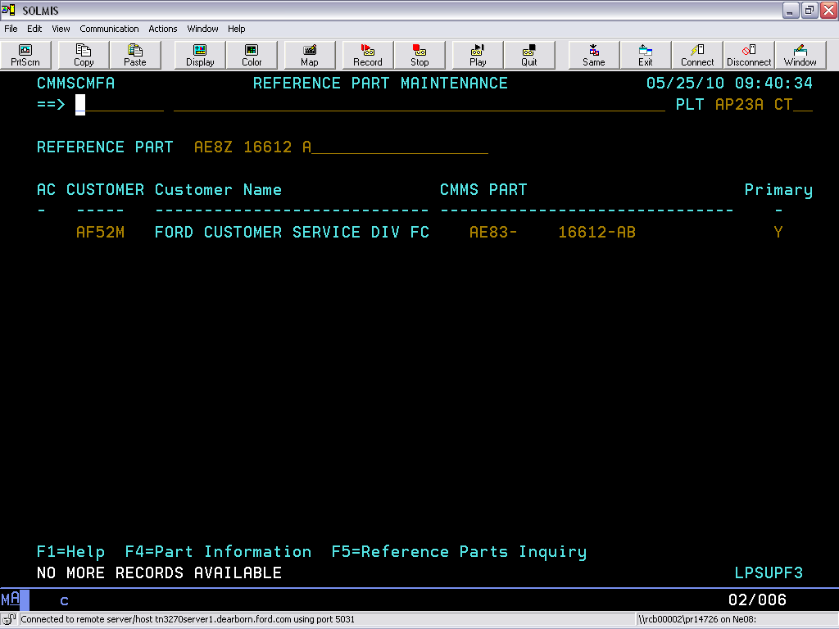
CAUTION: The part number in this data field MUST BE FORMATTED EXACTLY the way the customer is looking to electronically receive the part number.
This is a required field maintained on screen CMFA. Incoming customer releases with the customer's part number will be loaded against the plant's part number on screen BGHA when this field is set to "Y" (Yes).

  - Customer Profile (AAHA)
The Customer Profile has to be setup for AF52M in the Customer Profile (AAHA) screen in order for releases to properly enter the CMMS system. The plant "Parts Control Analyst" is usually the one that sets this up. (screen-print on next page)

Field | Y/N | Description
Service Customer | Y | Indicates this customer is a service customer.
Send Correct ASN | Y | This will allow replacement/cancellation ASN's to be sent.
Complex Consign | Y | If this is not "Y", AF52M will show as the ship to in BGHA instead of the packager code.

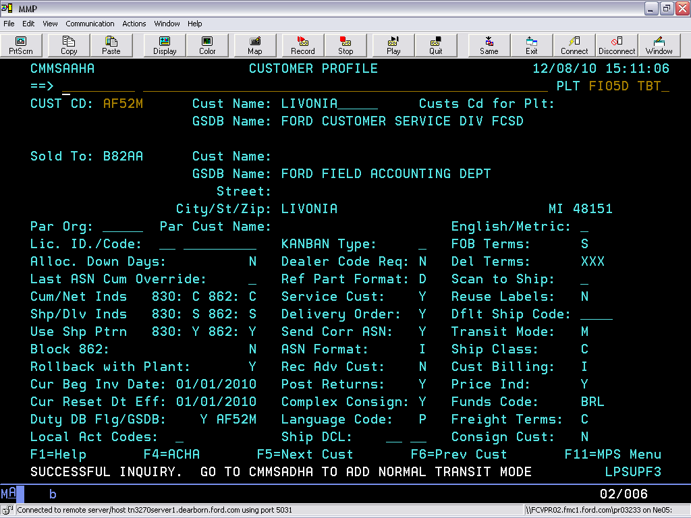

  - Dealer Direct ASN in CMMS
The Dealer Code (found on Referred Orders (ROLA) & Supplier Telegram (TGLA)* in IMS2) needs to reflect the Dealer that you are shipping to and the address (found on Supplier Telegram (TGLA)* needs to be overwritten with the Dealer's address. Process a change if necessary to reflect correct information. Remove the alt ship to if one exists on Customer Release Requirements Maintenance (BGHA) and Request For Shipper Header (AACA). [*Supplier Telegram (TGLA) can only be accessed from Referred Orders (ROLA)]

On Request For Shipper Header (AACA), create a PV shipper. The Ship To is the service GSDB that sent in the release: e.g. AF52M, AF31A, AF2KA, B82AA, etc. The sold to will populate based on Customer Profile (AAHA) set up.

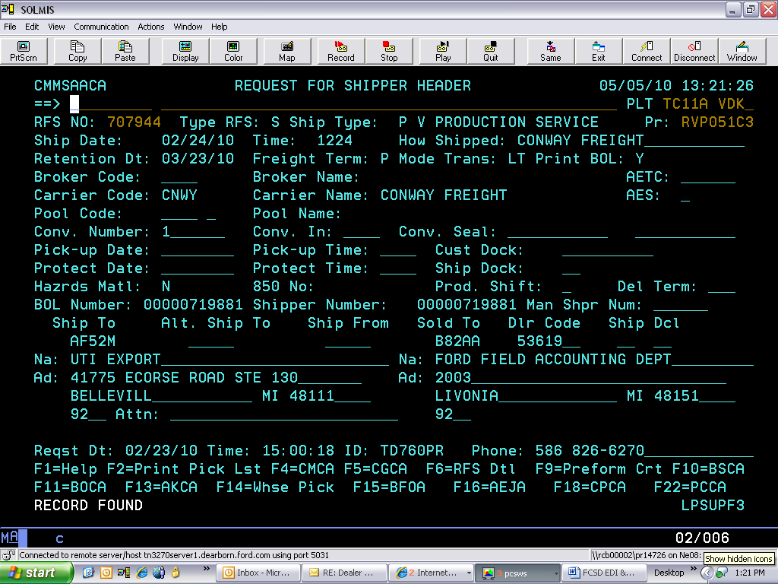
Alt. Ship To is where the Packager Code belongs, this must be blank
Enter the Dealer Code from ROLA here
Overwrite the Dealer Address here
Hit F6 to transfer to the ADCA Screen

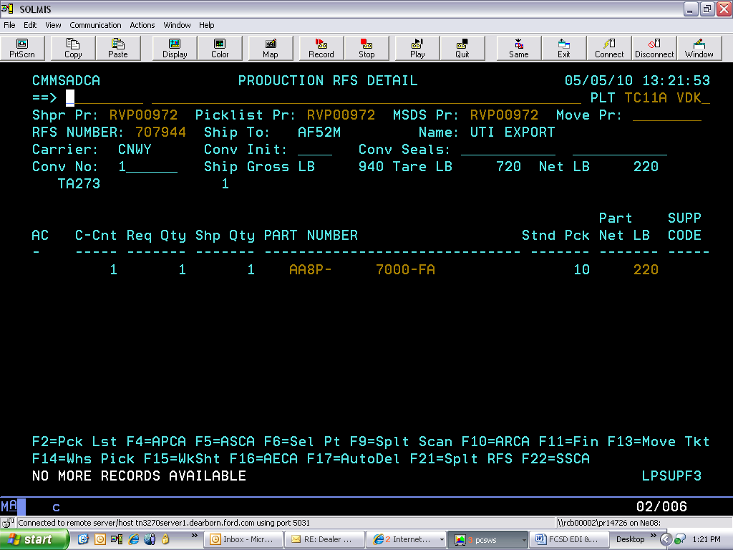
X
Place an 'X' in the A/C column and hit F16 (shift F4) to transfer to the AECA Screen.

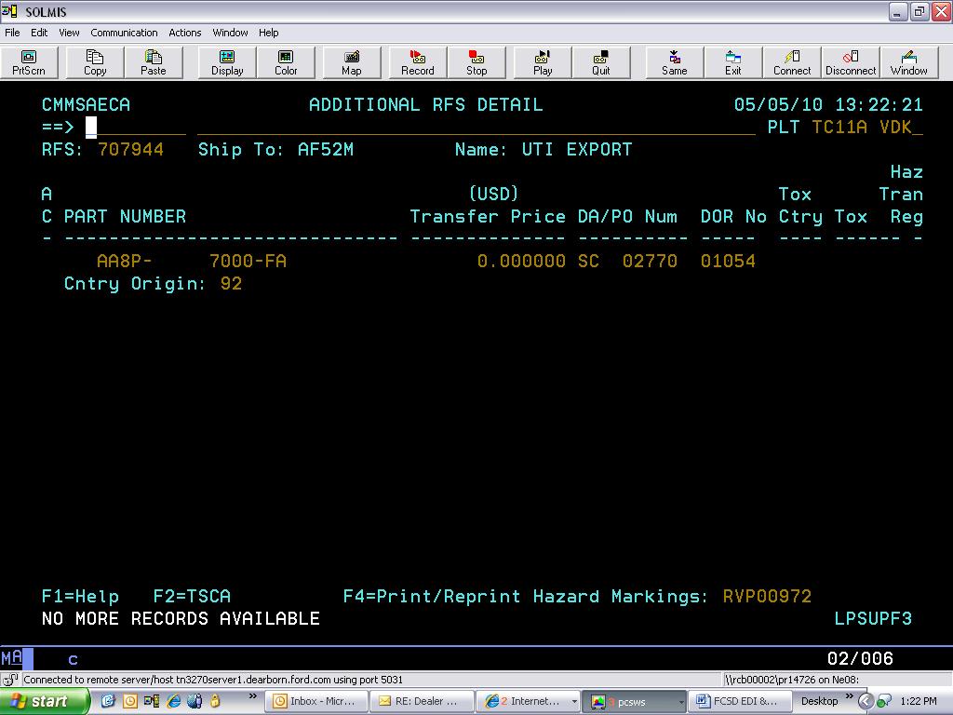
Add the DOR (Dealer Order Number) found on the ROLA & TGLA screens in IMS2 by processing a change on the detail row. Hit F12 to return to ADCA and finalize as usual
C

  - CMMS System Won't Allow Shipper
If the CMMS system won't allow shipper to be created without the Packager Code/Alt Ship To, you must remove it in the ship to field in Customer Release Requirements Maintenance (BGHA).

- Go to BGHA
- Place a "C" on the command line
- Remove the packager code from the "Ship To" field
- Hit enter

Note: Once the ASN has been sent, you must put the packager code back up on Customer Release Requirements Maintenance (BGHA) the same way you took it down.

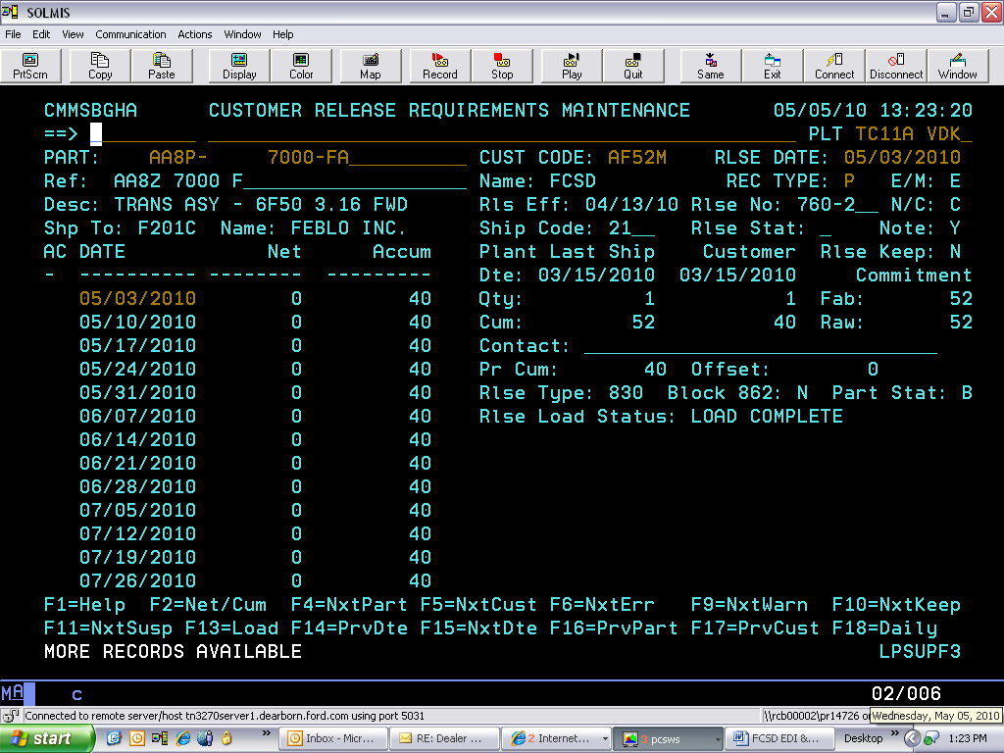
Alternant Ship To (Packager Code) has to be removed

  - Production Plants Service/Engineering #
Production plants that ship to FCSD are sent the service number. If they have their system setup correctly, the service number will show as the reference number in the Ref field.

  - Firm Requirements
Anything listed prior to the date in the FAB AUTH field in IMS2/DDL is considered firm.

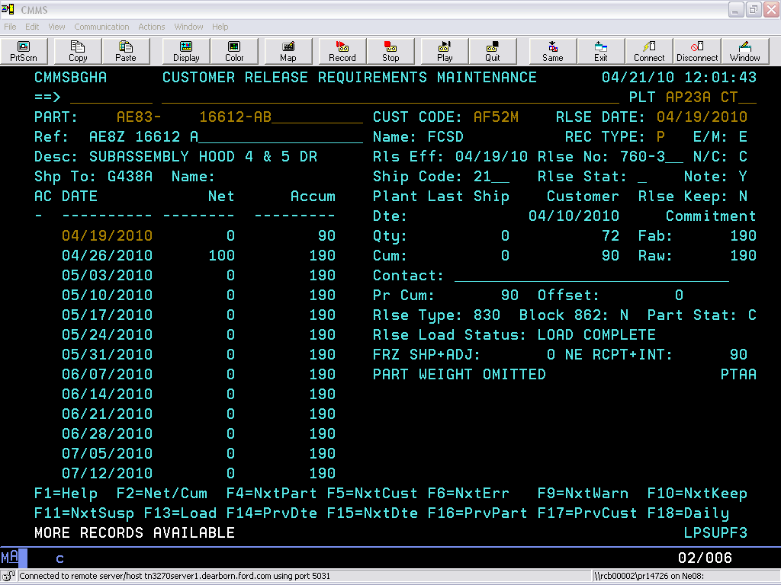
Reference Service #
Firm Requirement

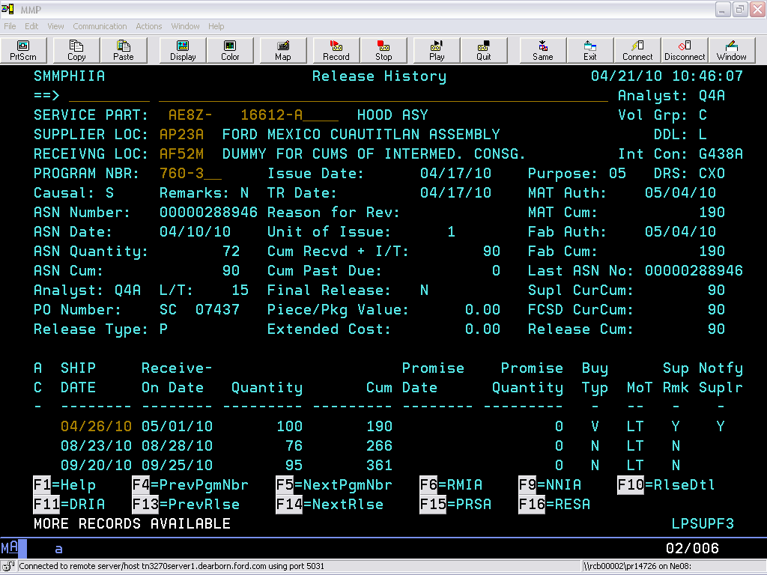
Firm Requirement

- MMOG/LE (Materials Management Operations Guideline/Logistics Evaluation)
Suppliers are required to establish a business process for continuous improvement by using the MMOG as a developmental tool. All suppliers for Ford North America are required to use the Global MMOG/LE Standard.

  - What is MMOG?
The Material Management Operations Guideline (MMOG) provides a comprehensive set of business procedures within the materials management function of an automotive manufacturing organization. It was designed to complement QS-9000 by detailing materials management requirements. It is targeted for all tiers of the supply chain, including raw material suppliers, logistics providers, parts and component suppliers, and re-packaging/sequencers.

  - AIAG (Automotive Industry Action Group)
Copies of MMOG/LE and electronic versions are made available to members of AIAG and are also available to non-members for a nominal fee. Further information can be obtained by visiting the website at www.aiag.org.

  - Accessing MMOG Instructions
Instructions for accessing MMOG.

- Log into Covisint
- Click on Ford Supplier Portal
- Click on Applications
- Click on the link MP&L 6 B2B Home Page
- Click on the link MP&L In A Box
- Click on the link MMOG/LE under MP&L References (on the left side of the page)

  - Assessment Criteria
The supplier location shall have key metrics defined, tracked, and displayed for all materials personnel to see. Industry recognized metrics include: build-to-schedule, ship-to-schedule, delivery performance from suppliers, record integrity, delivery performance to customers, and production metrics.

  - Management Responsibility
The supplier's Management shall define and document a materials policy, including objectives, an implementation timetable, and a firm commitment to understand and meet customer needs. Management shall ensure that the material policy is understood, implemented, and maintained throughout the organization
  - Self Assessment
Suppliers 'Self Assessment' must be submitted to the Supplier Development Analyst prior to launch.

- Q1 Delivery Performance
Supplier shall establish a business process to support FCSD Q1 Standards. Suppliers must achieve a minimum of 81 points on the Supplier Delivery Performance Rating for six (6) consecutive months before they are eligible to petition for Q1 Endorsement.

  - QC (Quality Control)
A supplier's STA Engineer (Supplier Technical Assistant) can be found on SIM.

  - Q1 Rating Measurements
Suppliers will be measured in the following categories:

- ASN Timeliness
- ASN Accuracy
- DDL Non-Compliance
- CUM Imbalances
- NOT (Not-On-Time)
- Early/Overshipment
- Shipping Discrepancy
- Emergency Response

- SIM PDC Dispute
Suppliers are required to dispute on-line from the 'Weekly Delivery Details' in SIM. The weekly on-line delivery dispute process gives suppliers an opportunity to dispute the majority of SDPR issues on-line instead of by fax or email. (Return to 11.0)

  - Weekly Delivery Details
It is required that suppliers review Weekly Delivery Details in SIM. Weekly Delivery Details are designed to be an early warning tool to assist suppliers in correcting potential issues which could impact their monthly SDPR (Supplier Delivery Performance Rating).

  - On-Line Dispute Manual
The Weekly PDC on-Line Dispute Manual, SDPR Point Scales, and Past Due Dispute information can be downloaded from Ford Customer Service Division (FCSD) Supplier Requirements resource [https://web.pslsupp.ford.com] located under (PDC) SIM/SDPR.

  - Disputing Point Loss
Suppliers can only dispute point-loss caused by FCSD via the on-line process in the following categories:

- NOT (Not-On-Time)
- DDL Non-Compliance
- Early/Over shipment

  - Dispute Not Available
If there is point-loss on the monthly SDPR rating that was not available to dispute on-line or in DDL, email the Dispute Analyst (Refer to 36.0) with concerns.

  - DDL System not Accessible
If the DDL System is not accessible due to Ford connectivity problems, obtain a problem ticket number from the SPoC Helpdesk at (888) 317-4957 or (313) 317-4957.

  - Conformances
Are not disputable through the Weekly On-Line Process or at Month End. Suppliers are required to handle these categories through DDL on the Supplier Follow-Up (SOSA) at the time of occurrence.

- EDICM - ASN Timeliness
- NOASN - ASN Accuracy
- CMBAL - CUM Imbalances
- INQTY - Shipping Discrepancies

  - Non-Disputable Issues

- Capacity
- Minimum Run Quantities
- Tier 2 Supplier Problems
- Minimum Ship Quantities
- Plant Shutdowns
- Ship Multiples
- Pricing/Cost
- Standard Pack
- Problem Reports

- Lead-Time (due to unanswered action message)
- Supplier System Problems
- No DDL Access (RACF ID)
- Vacation Coverage
- Supplier System
- Verbal Agreements
- Third Party Processing Issues
- Component Shortages

- Dispute Analysts

Supplier Dispute Analysts for FCSD-NA and FCSD-CA. (Return to 35.4)

Dispute | Analyst | Email | Phone
FCSD-NA Suppliers | Stephanie Tanzini | stanzini@ford.com | (734) 266-9863
Ford of Canada | Marjorie Passmore | MPassmo1@Ford.com | (905) 454-6244
Note: Emailed disputes are only accepted on issues that are not available to dispute through DDL or Weekly On-Line System. (Email dispute to your Supply Chain Analyst)

- Conformances
Conformances are generated by the system whenever the Supplier Location, Receiving Location, or Releasing Analyst deviates from the release schedule and the necessary adjustments are not made. They will also be displayed if an error is made when processing a shipment and/or receipt.

  - Supplier Service Part Remarks (RESA)
Suppliers are required to keep the information on Supplier Service Part Remarks (RESA) in IMS2/DDL updated.

- Timeliness (EDICM)
Verify conformance was disputed on the Reconciliation Detail (RSJA). When a supplier closes a conformance with a "Y", the issue is not disputable.

  - ASN Journal (AJAA)
The ASN Journal (AJAA) shows all ASN's processed by SOLMIS and forwarded to our DDL/IMS2 system whether the data content is correct or incorrect. ASN timeliness can be viewed in the ASN Journal.

  - Penalization
The supplier is penalized when the process date of the ASN indicates a later date than the ship date on the ASN.

- Accuracy (NOASN)
Verify conformance was disputed on the Reconciliation Detail (RSJA). If supplier closed conformance with a "Y", the issue is not disputable.

  - Transaction Register (TABA)
ASN accuracy data can be viewed in the Transaction Register (TABA), it will be posted as a 67 Transaction Code (stock in-transit).

  - Unable To View 67 Transaction
If no 67 transaction is showing in the Transaction Register (TABA), go to Supplier Follow-Up (SOSA) to check for suspended ASN. Suspended ASN's will not show in Transaction Register (TABA), but will show on the ASN Journal (AJAA).

  - ASN Journal (AJAA)
To view the ASN in the ASN Journal (AJAA). (Refer to the DDL Manual for the ASN Edits).

- Type an "X" in the A/C column next to the ASN to be researched.
- Press the F5 key to review the Formatted Data of the ASN Detail (ADAA) for errors.

  - Penalization
The supplier is penalized and service part numbers are considered not shipped when a valid/accurate ASN was not received and processed.

- Early/Overshipments
Review the Release History (HIIA) displaying requirements and the Transaction Register (TABA) showing receipts. Review the ASN Journal (AJAA) to verify ship date and quantity.

  - Penalization
Suppliers are penalized when the Release History (HIIA) Requirement, ASN Quantity, and Ship Week Date do not agree.

- DDL Non-Compliance
Review Supplier DDL Performance Summary Screen (DSSA) including the back-up screens Non-Conformance Detail (CNSA), Non-Conformance Promise Detail (PNSA), and Non-Conformance Quality Detail (QNSA) in the DDL/IMS2 system.

- Promise Accuracy

FCSD PDC suppliers are currently not measured and will receive full points for this category.

- Shipping Discrepancies (INQTY)
Verify that conformance was disputed Reconciliation Detail (RSJA) and the "Perform Include" flag is set to "N". If the supplier closed the conformance with a "Y", the issue is not disputable.

  - Transaction Register (TABA)
Review the Transaction Register (TABA) for discrepant quantity that will show as a 65P Trans Code.

  - Provide Remarks
Provide remarks in Reconciliation Detail (RSJA) showing correct quantities were shipped.

  - Penalization
Supplier is penalized when the shipping discrepancy is caused by the supplier.

- NOT (Not-On-Time)
This category measures current month releases. FCSD considers the stock not shipped and NOT WHEN the Release History (HIIA) reflects a requirement and an accurate ASN has not been issued.

  - Reviewing
Review disputed service part number on the Release History (HIIA) for the disputed month. Review the Transaction Register (TABA) to verify an ASN that shows as a 67 Trans Code in Transaction Register (TABA) was processed.

  - Check ASN Journal (AJAA)
If the ASN cannot be located on the Transaction Register (TABA), check for a suspended ASN on Supplier Follow-Up (SOSA), and review the ASN for errors on ASN Detail (ADAA) [F5 from ASN Journal (AJAA)].

  - Supplier Service Part Remarks (RESA)
Verify the issue was documented on the Supplier Service Part Remarks (RESA) Screen.

  - Dispute
Dispute if there are valid reasons why parts were not shipped and ensure those reasons are on the RESA Screen prior to the service part number being NOT.

  - Carrier Compliance Form
When a carrier does not show and as a result causes NOT, include a Carrier Compliance Form (Refer to 15.0).

- CUM Imbalance (CMBAL)
Identifies a CUM Imbalance indicating that an ASN was processed and the CUM s hipped on the supplier's ASN does not match FCSD's seed CUM (CUM received plus in-transit).

  - Conformance Disputed
Verify conformance was disputed on the Reconciliation Detail (RSJA) and the "Perform Include" flag is set to 'N'. If supplier closes the conformance with a 'Y', the issue is not disputable.

  - Review
Verify conformance was disputed on the Reconciliation Detail (RSJA) and the "Perform Include" flag is set to 'N'. If supplier closes the conformance with a 'Y', the issue is not disputable.

  - ASN Journal (AJAA)
From the AJAA screen place an 'X' next to the ASN to be researched, press 'F5', and review the supplier total CUM shipped in the ASN Detail (ADAA).

  - CUM Disagreement
If the total CUM shipped on the supplier's ASN does not agree with the total CUM received on the Transaction Register (TABA), compare supplier shipment with FCSD receipts since the CUM Reset/Rollback for the discrepancy.

- Past Due

This category measures previous monthly open releases.

  - Review
Review the disputed service part number on the Release History (HIIA) for the disputed month. Review the Transaction Register (TABA) to verify an ASN shows as a 67 Trans Code, was processed.

  - ASN Not Showing
If an ASN is not showing on the Transaction Register (TABA), check Supplier Follow-Up (SOSA) for suspended ASN, ASN Journal (AJAA), and ASN Detail (ADAA) for the error on the ASN. When the Release History (HIIA) reflects a requirement and an accurate ASN was not sent, FCSD Considers the stock not shipped and therefore, past due.

  - Document
Verify the issue was documented on the Supplier Service Part Remarks (RESA).

  - Dispute
Dispute if there are valid reasons why a service part number was not shipped (and that those reasons are on Supplier Service Part Remarks (RESA), prior to the part being NOT).

- Emergency Order Responsiveness

Currently FCSD PDC Suppliers are not measured for this category.

- FCSD Intermediate Consignees (Contract Packagers)
Contract Packager's Physical Addresses and Phone numbers. (Return to 24.9) (Return to 30.4)

Code | Name | Street | City | State | Zip | Phone
A428A | ADM Logistics | 4115 8th St. | Wyandotte | MI | 48192 | (313) 382-3900
AF30A | Parts Redistribution Center | 25555 Pennsylvania Rd. | Romulus | MI | 48174 | (734) 942-6298
AF30E | Parts Redistribution Center | 24999 Pennsylvania Rd. | Brownstown | MI | 48174 | (734) 942-6192
B969F | Butcher Engineering | 17579 Mockingbird Rd. | Nashville | IL | 62263 | (618) 478-2267
D471A | Diesel Equipment | 578 East Main St. | Potterville | MI | 48876 | (517) 645-7684
DTK3A | Fapco Inc. | 16261 Bakertown Rd. | Buchanan | MI | 49107 | (269) 695-6889
F201C | Hollingsworth Logistics (HLM) | 14231 West Warren Ave. | Dearborn | MI | 48126 | (313) 768-1441
F201M | Hollingsworth Logistics (HLM) | 8211 Decantur St. | Detroit | MI | 48228 | (313) 768-1441
FJU8A | Menlo Worldwide Logistics | 601 South Royal Ln. | Coppell | TX | 75019 | (972) 318-6050
F747A | Howard Ternes Packaging | 12285 Dixie St. | Redford | MI | 48239 | (313) 531-5867
G438A | The Gerstenslager Company | 1425 East Bowman St. | Wooster | OH | 44691 | (330) 262-2015
H751B | HLG Texas Operations | 5925 Tri-County Pkwy STE 100 | Schertz | TX | 78154 | (210) 651-0007
P025A | Pak Rite Industries | 4270 High St. | Ecorse | MI | 48229 | (313) 388-6400
P7AKA | Ternes Packaging | 12285 Dixie St. | Redford | MI | 48239 | (313) 531-5867
Q9XYA | Hollingsworth Logistics (HLM) | 14225 West Warren Ave. | Dearborn | MI | 48126 | (313) 768-1326
T080H | Howard Ternes Packaging | 910 Detroit Ave. | Monroe | MI | 48162 | (313) 531-5867
V366C | Venchurs Packaging | 800 Tabor St. | Adrian | MI | 49221 | (517) 266-5772
W953A | Woodspecs Inc. | 2240 Scott Lake Rd. | Waterford | MI | 48328 | (248) 674-0968

- FCSD Network Locations/PDC (Part Distribution Centers) (Return to 30.4)

Network Locations/PDC's Physical Addresses and Phone Numbers.

Code | Name | Street | City | State | Zip | Phone
AF1DA | FCSD Atlanta Parts | 100 Constitution Dr. | McDonough | GA | 30253 | (770) 914-3131
AF1JA | Ford Memphis PDC LVLC | 5345 Hickory Hill Rd. | Memphis | TN | 48141 | (901) 547-8718
AF1KA | Ford Memphis PDC HVC | 5345 Hickory Hill Rd. | Memphis | TN | 38141 | (901) 547-8718
AF1LA | Ford Sacramento PDC HCC | 1260 Phoenix Dr. | Manteca | CA | 95336 | (209) 824-6623
AF1MA | Ford Detroit PDC HCC | 25640 Pennsylvania Rd. | Romulus | MI | 48174 | (734) 942-6372
AF1NA | Ford Houston PDC HVC | 7909 Northcourt Rd. | Houston | TX | 77040 | (713) 744-1875
AF1PA | Ford Fort Worth PDC HVC | 4750 Liberty Way | Fort Worth | TX | 76177 | (682) 831-2373
AF1QA | Ford Phoenix PDC HVC | 1411 S. 47th Ave. Suite 100 | Phoenix | AZ | 48043 | (602) 442-6411
AF1RA | Ford Ontario PDC HVC | 8449 Milliken Ave. | Rancho Cucamonga | CA | 91730 | (909) 484-5143
AF1SA | Ford Portland PDC HVC | 8929 N. Ramsey Blvd. | Portland | OR | 97203 | (503) 978-1201
AF1TA | Ford Sacramento PDC HVC | 1260 Phoenix Dr. | Manteca | CA | 95336 | (209) 824-6623
AF1UA | Ford Hartford HVC | 110 Country Circle | Windsor Locks | CT | 06096 | (860) 292-3601
AF1VA | Ford Washington DC HVC | 170 Shady Elm Rd. | Winchester | VA | 22602 | (540) 545-4402
AF1WA | Ford New York HVC | 280 Prospect Plains Rd. | Cranbury | NJ | 08512 | (609) 395-6501
AF1XA | Ford Twin Cities HVC | 5700 Badger Dr. | Menomonie | WI | 54751 | (715) 233-5819
AF1YA | Ford Evansville PDC HVC | 1980 South 100 West | Princeton | IN | 47670 | (812) 386-2520
AF1ZA | Ford Chicago PDC HVC | 12525 S. Carondolet Ave. BLDG 4 | Chicago | IL | 60633 | (773) 892-3516
AF2AA | Ford Denver PDC HVC | 4401 Florence St. | Denver | CO | 80238 | (720) 374-7067
AF2BA | Ford Kansas City PDC HVC | 8515 Hedge Lane Terrace | Shawnee | KS | 66227 | (913) 667-1201
AF2CA | Ford Lakeland PDC HVC | 210 Deen Still Rd. | Davenport | FL | 33897 | (863) 420-4602
AF2DA | Ford Greensboro PDC HVC | 1099 Corporate Park Dr. | Mebane | NC | 27302 | (919) 304-8409
AF2EA | Ford Atlanta PDC HVC | 175 Greenwood Industrial Pkwy. | McDonough | GA | 30253 | (770) 305-7286
AF2FA | Ford Detroit PDC HVC | 19991 Brownstown Center Dr. STE 960 | Brownstown | MI | 48183 | (734) 479-3821
AF2GA | Ford Memphis PDC HVC | 4880 Tuggle Rd. | Memphis | TN | 38118 | (901) 368-8820
AF2KA | Ford Export HVC | 25360 Pennsylvania Rd. | Romulus | MI | 48174 | (734) 942-6357
AF30A | Ford Parts Redistribution Center | 25555 Pennsylvania Rd. | Romulus | MI | 48174 | (734) 942-6298
AF31A | National Parts Distribution Center | 11871 Middlebelt Rd. | Livonia | MI | 48151 | (734) 523-3265
CA02G | Ford Motor Canada NPDC | 11640 181st St. | Edmonton, AB Canada | CA | T5S 1M6 | (780) 454-9621
H0TDC | UTI (TDS) | 41775 Ecorse Rd. STE 130 | Belleville | MI | 48111 | (734) 957-1600
L9V0C | UTI (TDS) | 41775 Ecorse Rd. STE 130 | Belleville | MI | 48111 | (734) 957-1600
R3MSA | UTI (TDS) | 41775 Ecorse Rd. STE 130 | Belleville | MI | 48111 | (734) 957-1600

Key

Key
HCC | High Cube Center
HVC | High Velocity Center
LVLC | Low Volume Low Cube
PDC | Parts Distribution Center
PRC | Parts Redistribution Center

- Covisint
Covisint information and Helpdesk.

  - Identifying your CSA

- Go to http://us.register.covisint.com
- Login with your Covisint ID and password
- Click on My Administrators
- CSA(s) will be listed under Security Administrator(s)

  - Covisint Helpdesk
Issues related to Covisint Access or any applications within Covisint should be directed to their helpdesk. You can find a listing of all the phone numbers by Country at this website: https://portal.covisint.com/web/supportauto/contactus or by clicking on Support.

Helpdesk | Toll Free | Direct Dial
Covisint Helpdesk | (866) 273-5038 | (248) 365-2525
Covisint Request Tracker | https://crt.covisint.com/
Covisint Knowledge Base (FAQ) | https://portal.covisint.com/web/supportauto/kbase

  - Assigning A New CSA
If your Security Administrator has left the company and you have to assign a new one.

- Determine who the new Security Administrator should be.
- The new Security Administrator can send an email to portalsupp@covisint.com requesting the change.

  - Covisint Knowledge Base (FAQ)
You can find the answers to most of your Covisint questions in the Covisint Knowledge Base (FAQ).

- Covisint Registration

Use the following step-by-step instructions to register for Covisint. (Return to 1.1)

  - Web Link

Go to https://us.register.covisint.com/start.html, and click on "New User".

Click <begin registration>.

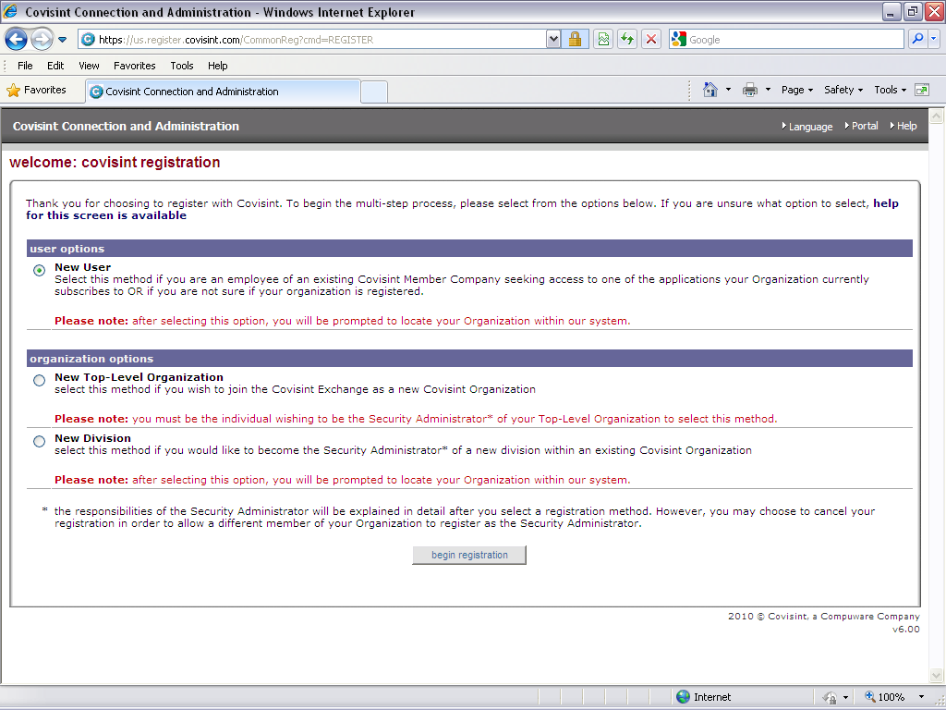

  - Find Organization
Enter the "Organization" and click <search> or enter the "Supplier Code" and click <search>.

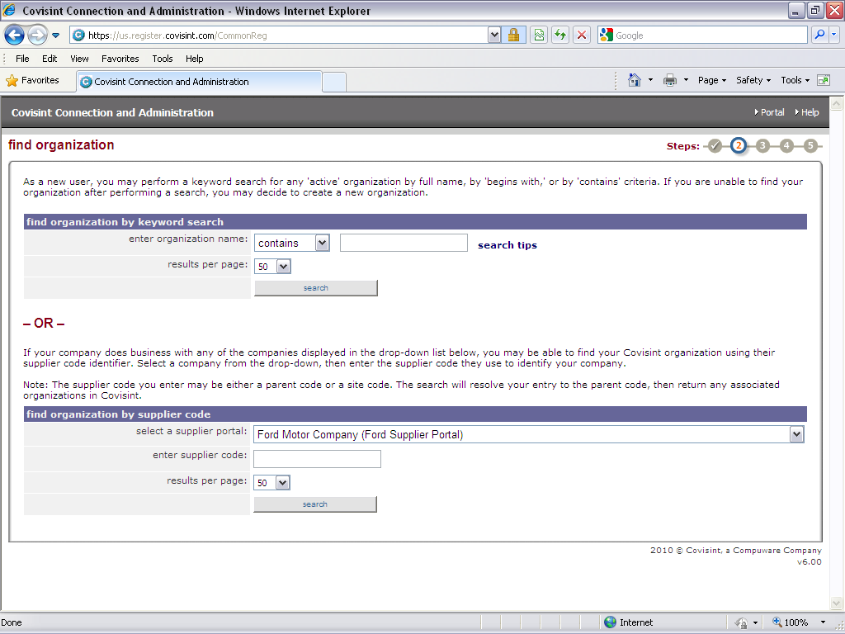
Enter Organization Name

OR

Supplier Code

  - Search Results
Select the company from the search results screen and click on <continue registration>.

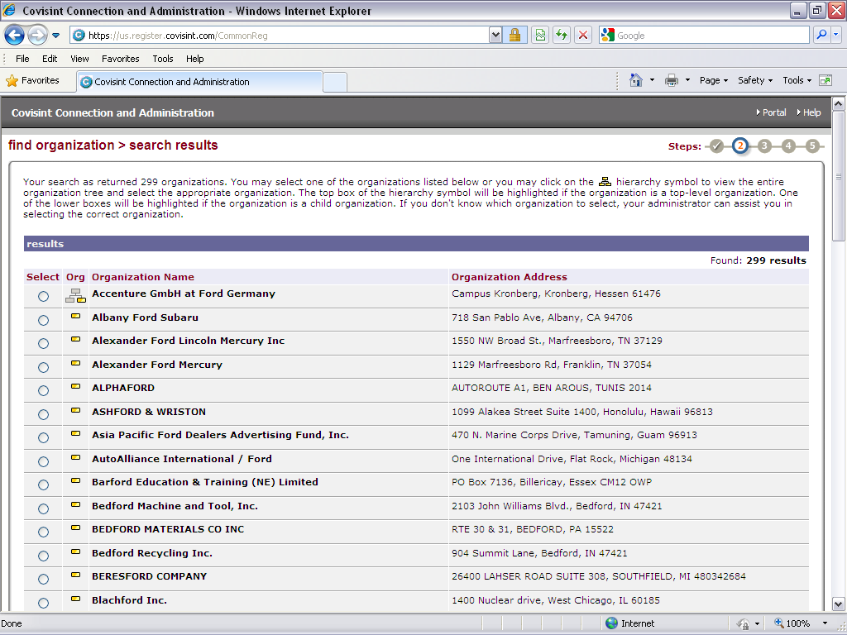

  - Complete Form
Fill out all the required fields. Click <continue registration>.

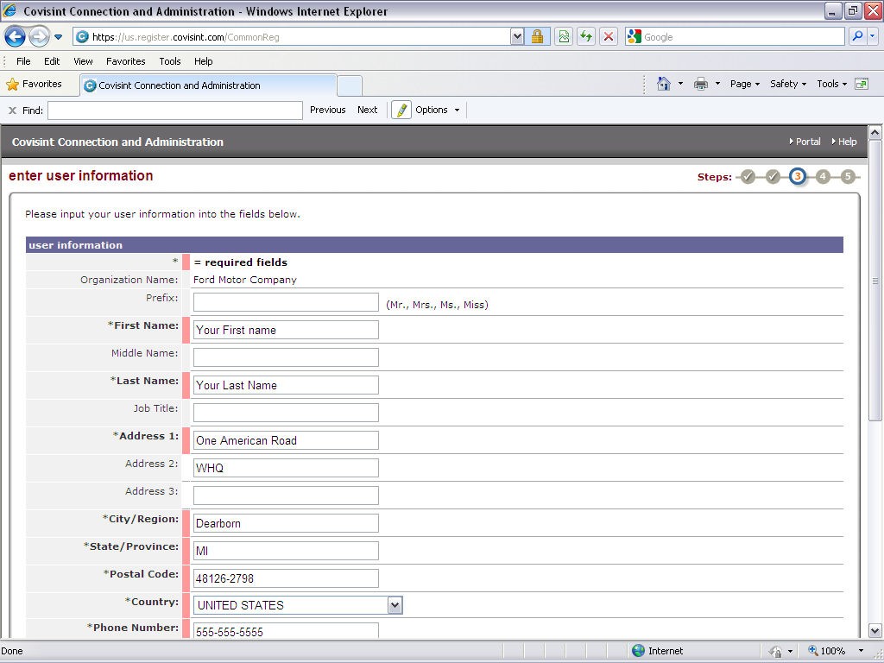

  - User Information
Create a User ID, Password, and Challenge Question, click on <continue registration>.

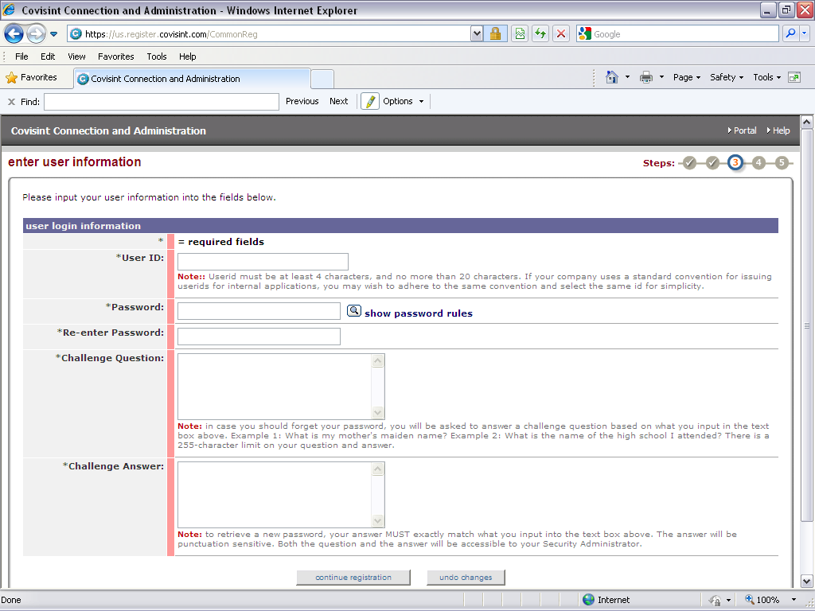

  - Applications
Select Ford Supplier Portal and/or other desired portals or applications. Click <continue>.

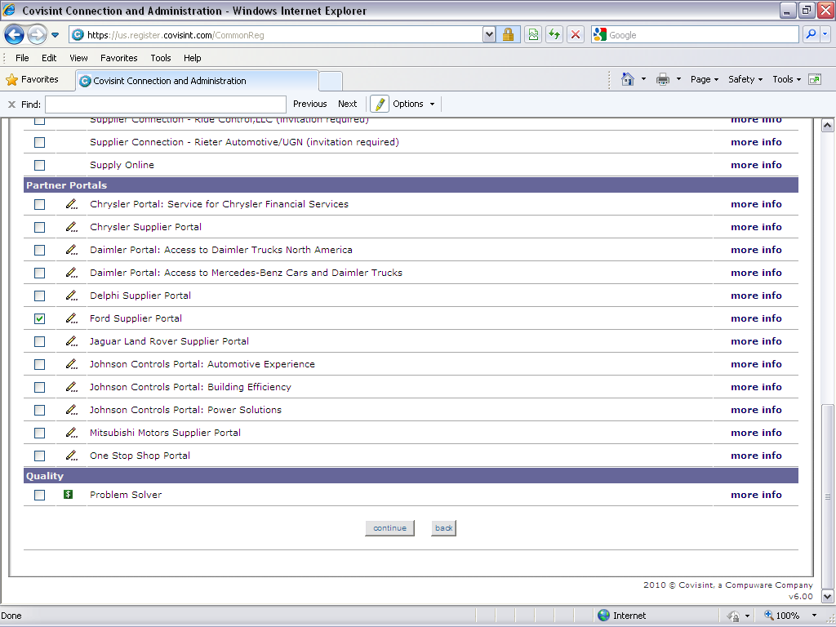

  - Location Code
Enter "Supplier Code". Click <continue registration>.

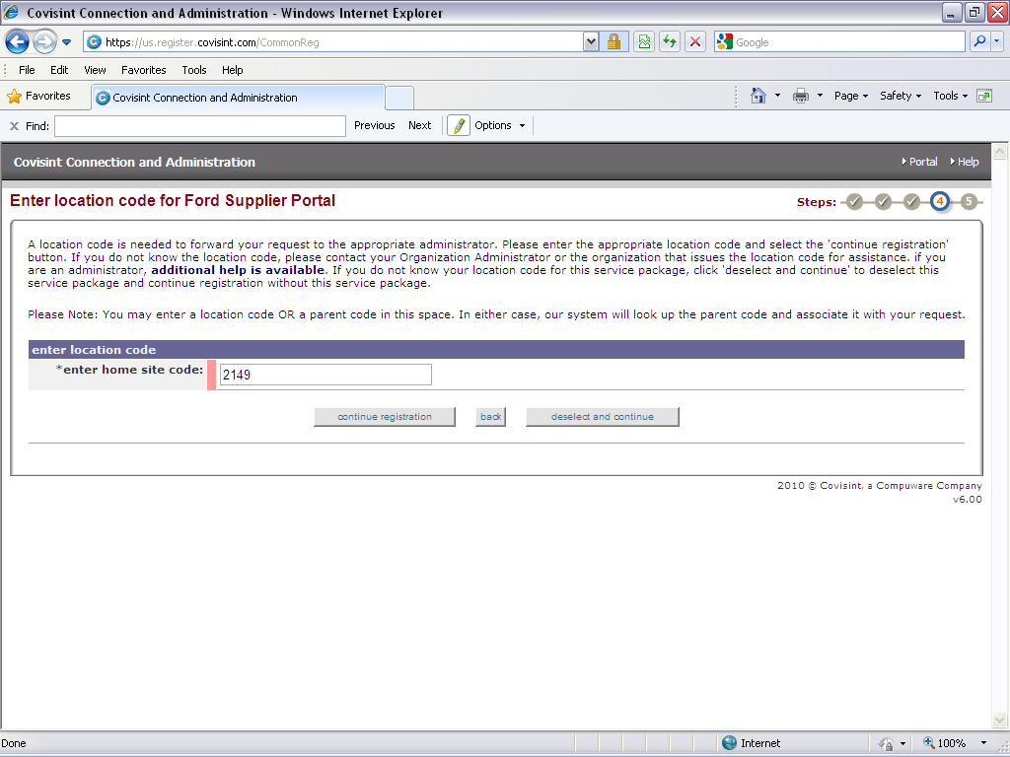

  - Company CSA
Click <Yes, I accept agreement>, verify the registration and submit to your company's CSA for approval.

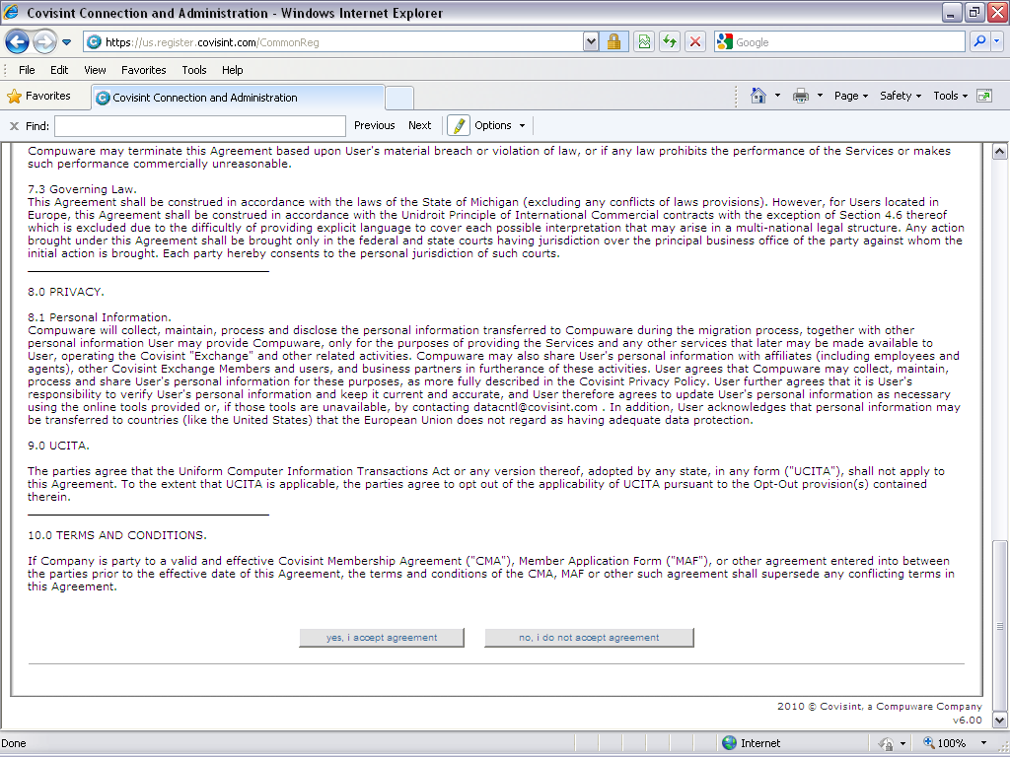

- Adding Ford Supplier Portal
Once you have registered for Covisint, follow these steps to add Ford Supplier Portal Access to your "Covisint User Profile". (Return to 1.2)

- Logon to Covisint at www.covisint.com
- Click Administration Tools
- Mouse over "My Profile" and click View My Profile
- Click Request Service Package
- Check the box next to "Ford Supplier Portal", click Request
- Follow the prompts to complete

Note: Once these steps are completed, an email will be sent to your CSA for approval. Once you are granted access, you will need to logout and logon again to your Covisint user account to refresh your profile with the newly granted access. If you have any issues adding access or with these instructions, please contact the Covisint Helpdesk.

- Accessing DDL (Direct Data Link)

Follow the steps outlined to access DDL (Direct Data Link/IMS2) for Ford Service through Covisint.

  - Covisint
Users must navigate through the Covisint Portal https://portal.covisint.com. Enter User ID and Password. Click <Login>

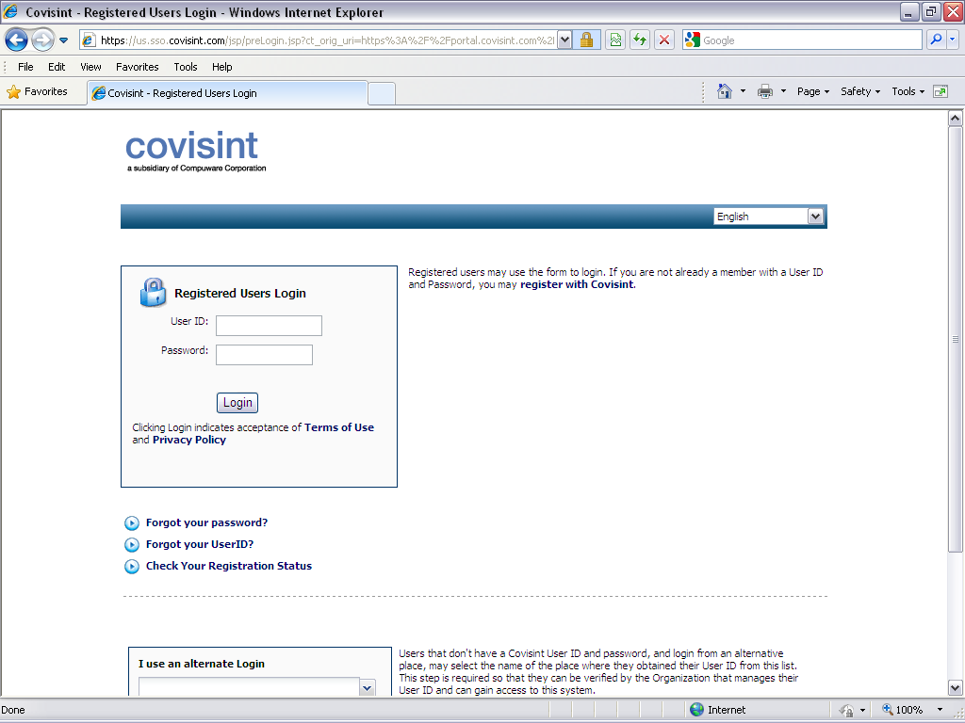

  - Click on Ford Supplier Portal

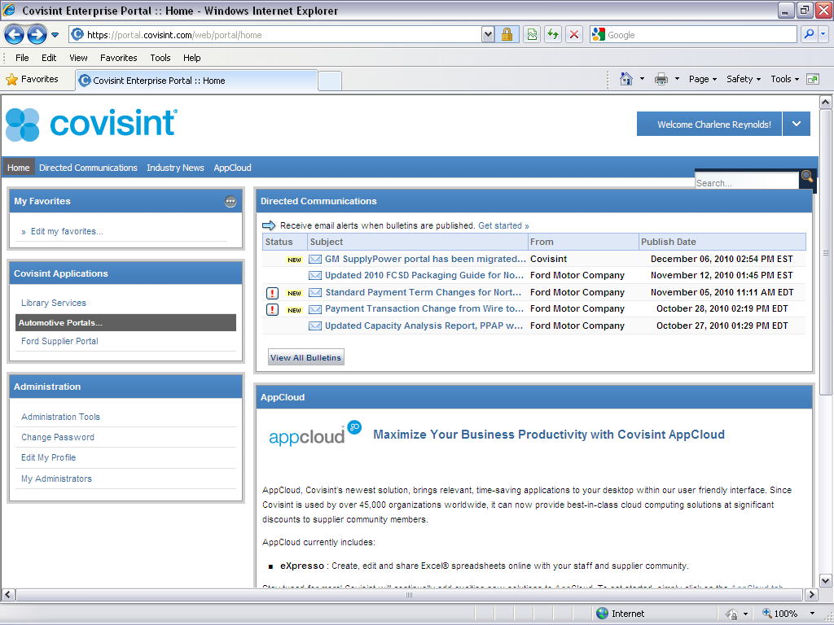

  - Click On Applications

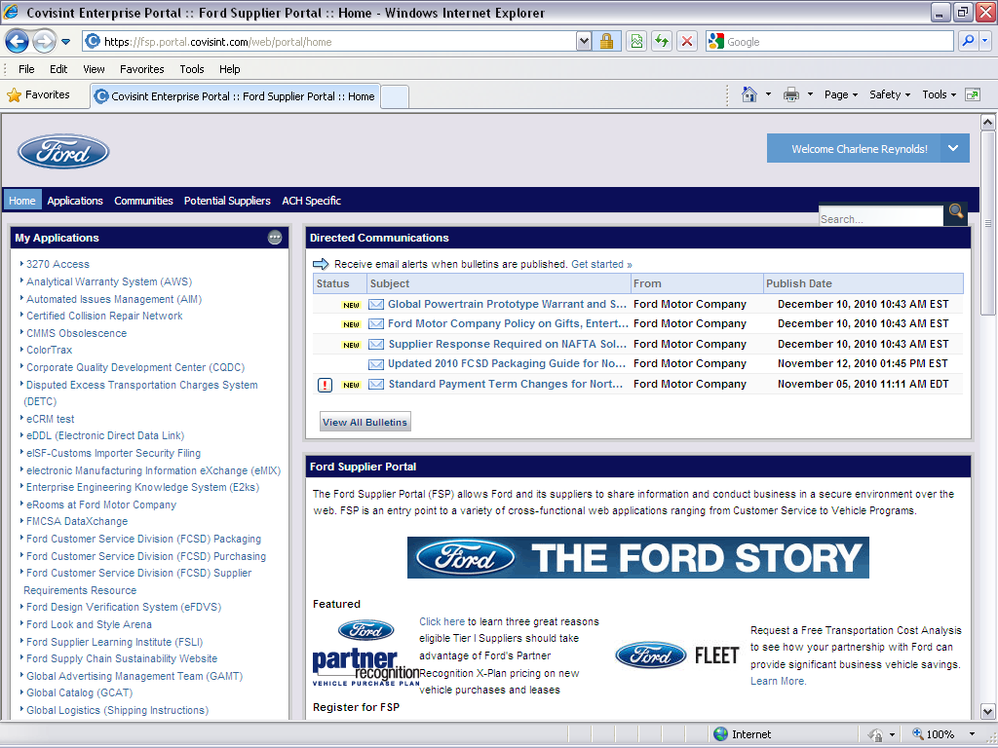

  - Click On 3270 Access

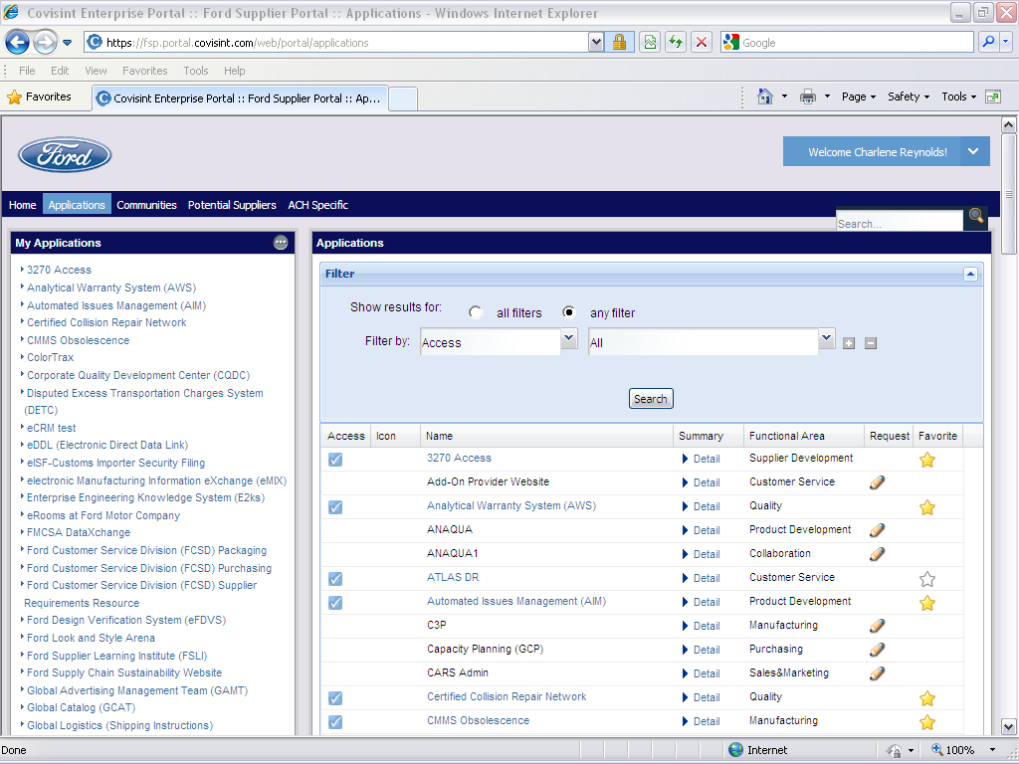

  - Click "Run 3270 Application"
You will need to be sure that you turn off any POP-UP Blockers or the WebConnect Client will not launch.

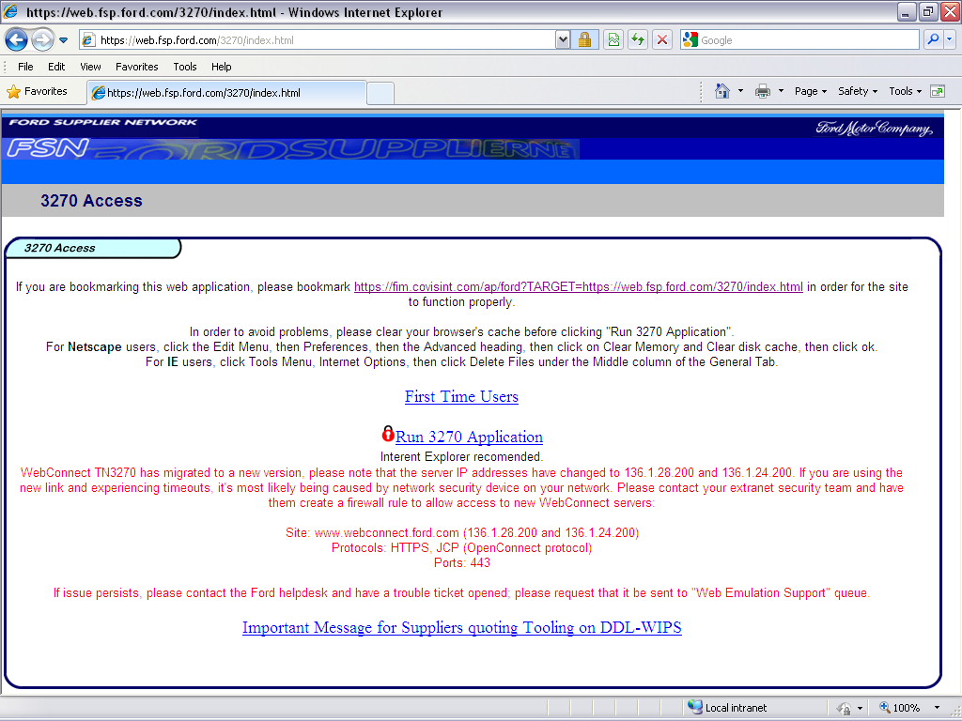

  - Security Warning
If you receive this warning, Click <No>, choosing Yes may cause a "Navigation to the webpage was canceled" error.

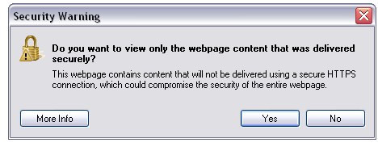

  - Pop-Up Blocker
You will need to be sure that your Pop-Up Blockers are disabled. The Ford WebConnect will not launch if you block Pop-Ups.

  - WebConnect Client
The WebConnect Client will need to remain open until you exit.

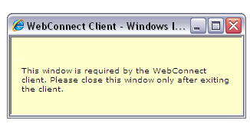

  - WebConnect Launched
Type IMS2 next to "Enter" then hit the <Enter> Key.

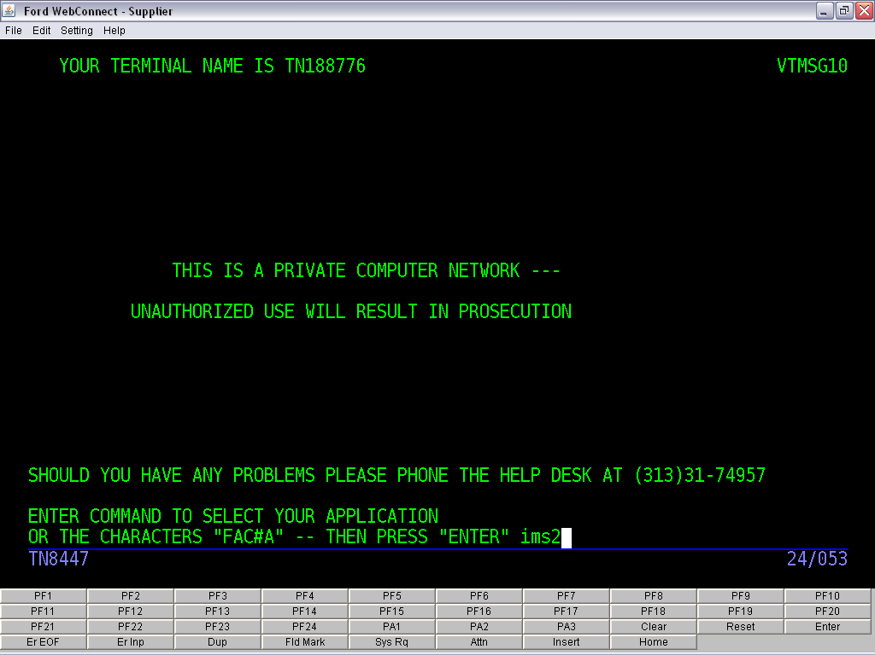

  - User ID and Password
Type your RACF ID and Password in the USER ID and PASSWORD fields. If you do not have a RACF ID (Refer to 2.3), you will not be able to access the system.

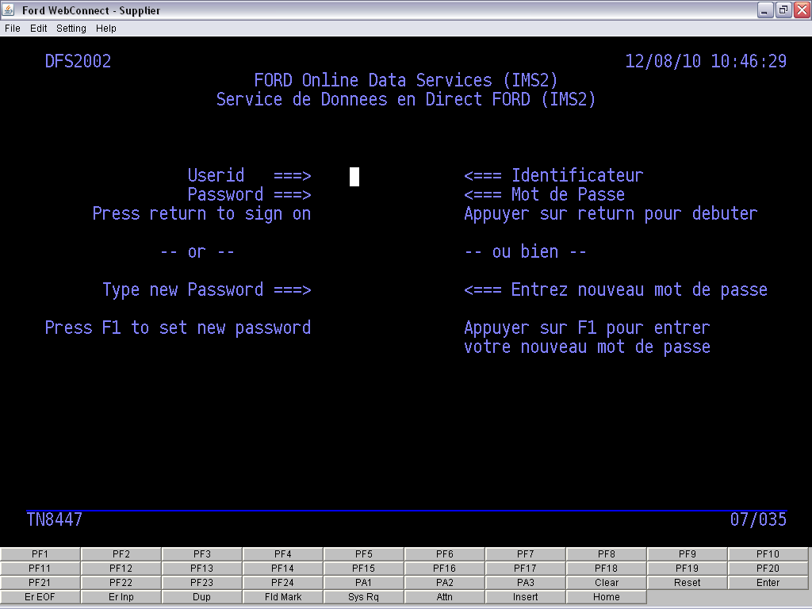

  - FCSD Corporate Applications
Type a 'P' in this field and press <Enter>.

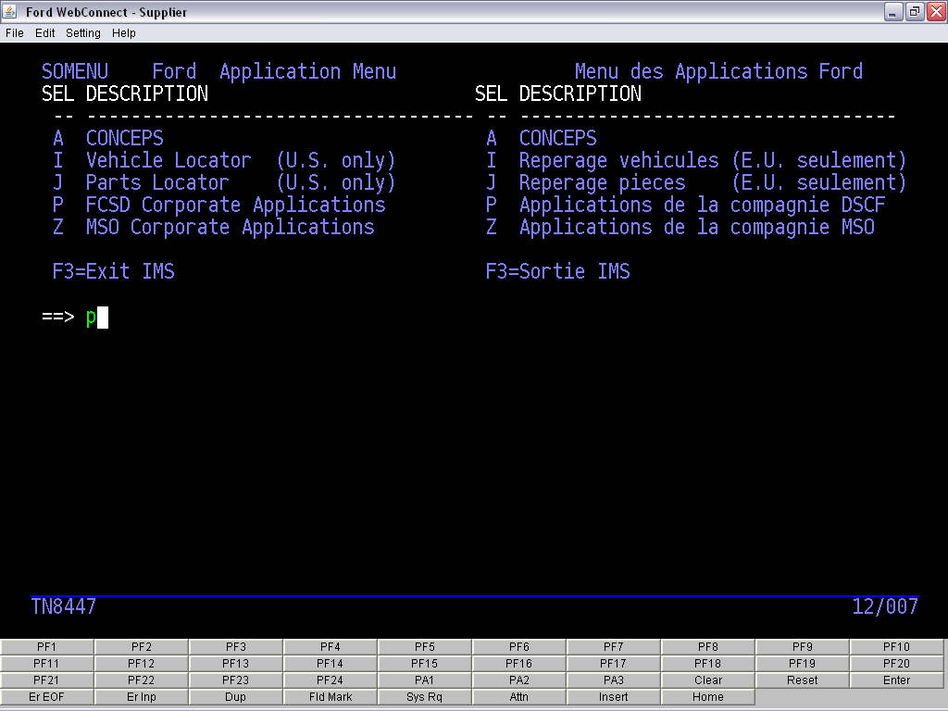

  - Supplier Follow-Up (SOSA)
To review the Supplier Follow-Up (SOSA), type 'GSMMPSOSA' on the command line and press <Enter>.

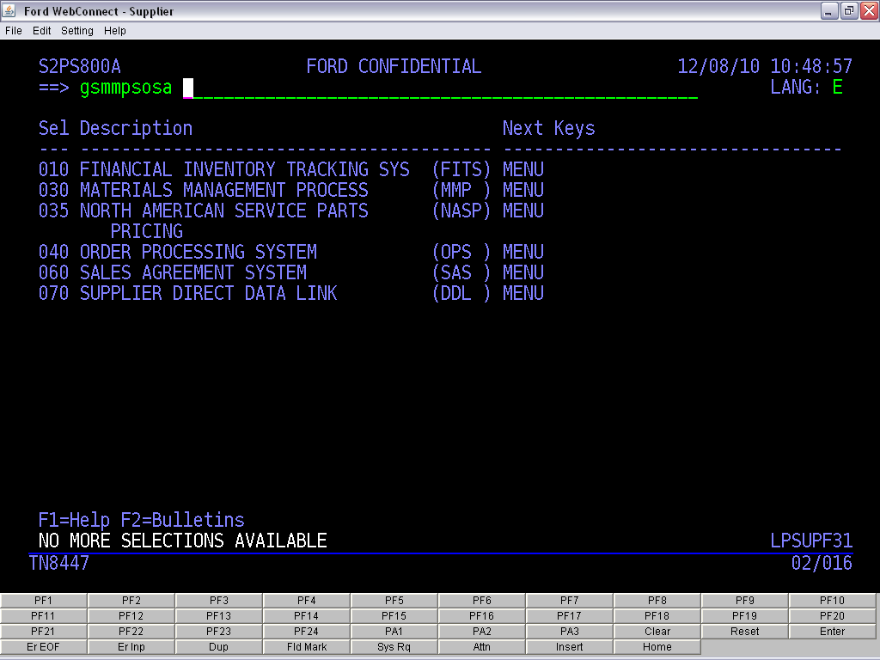

  - Populating Supplier Follow-Up (SOSA)
If your Supplier Code is not showing, type it in the "Supplier Location" filed. Press <Enter>. To populate the categories, type the number associated with the category you want to view (under GROUP) in the GROUP field.

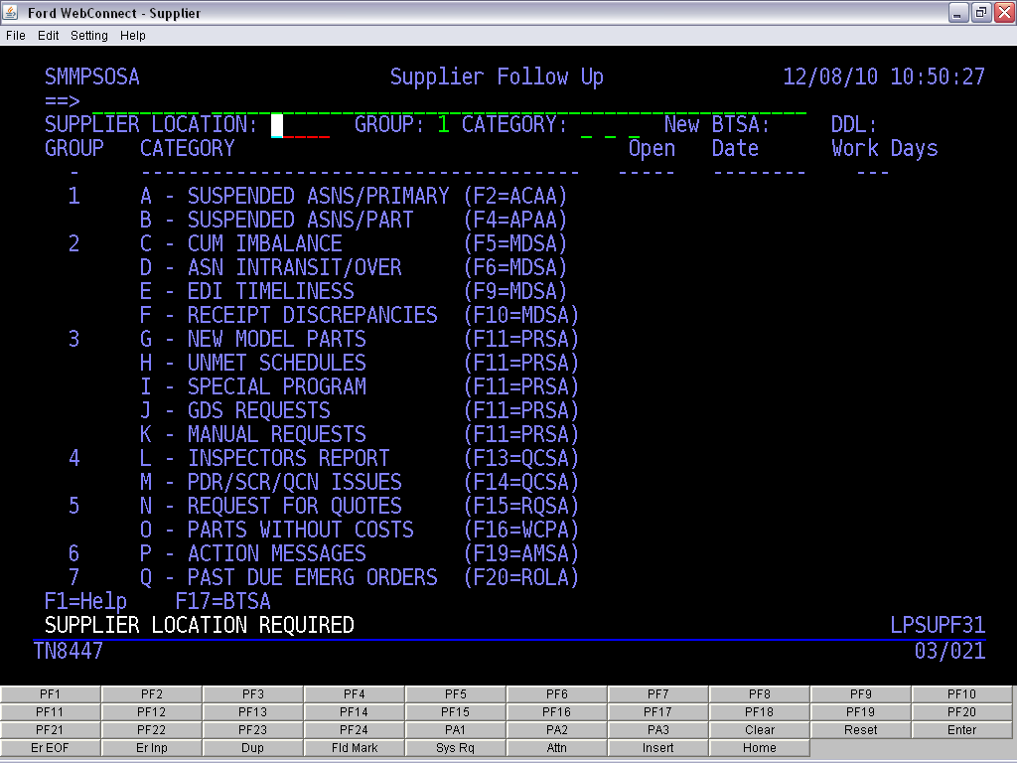

  - All Categories
To populate all categories, hit <Enter> after each group number entered 1-7.

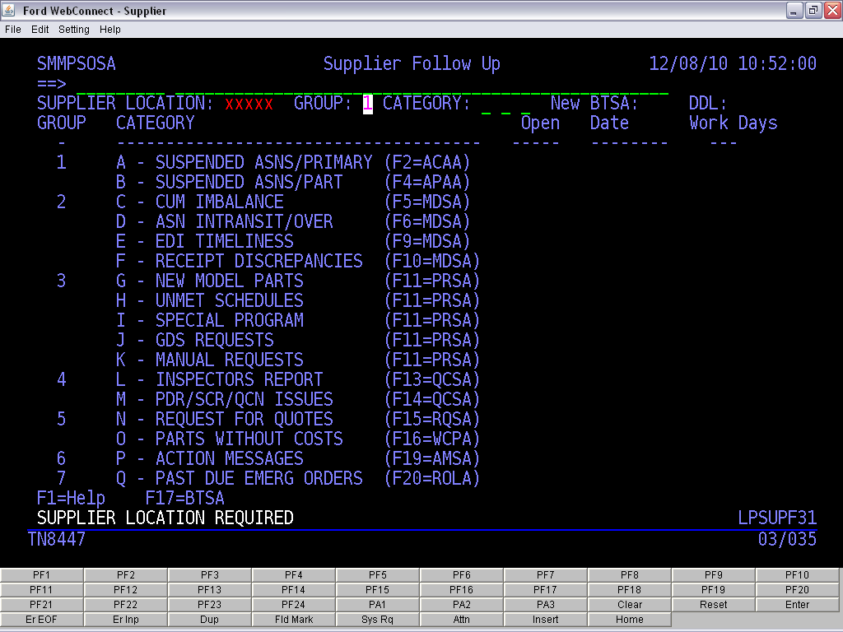
- DDL/IMS2 Supplier Screens
Below is a list of screens that suppliers have access to in the DDL/IMS2 system.

Screen | Screen Name | Description
SOSA | Supplier Follow-up | Displays a summary of open issues.
ASN SCREENS
*ACAA | ASN Correction - Primary Control Record | Displays Invalid/Ineligible receiving location errors.
ADAA | ASN Detail (F4) - Unformatted ASN Data  ASN Detail (F5) - Formatted ASN Data  ASN Detail (F6) - ASN History | Displays Unformatted (CIF) ASN detail.  Displays Formatted ASN detail.  Displays the History of the ASN.
AJAA | ASN Journal | Displays all ASN's valid or suspended.
*APAA | ASN Part Level Record Errors | Displays service part level errors (invalid P/N).
DCAA | Conveyance | Displays in-transit or booked conveyances.
PPAA | Parts Processing Detail | Displays detailed information for an ASN on a conveyance.
TPAA | In-Transit Parts | Displays all service parts currently in-transit.
CONFORMANCE SCREENS
MDSA | Reconciliation Listing | Displays all conformances requiring supplier resolution.
*RSJA | Reconciliation Detail | Displays detailed information associated with a conformance.
PROMISE DATE SCREENS
*PRSA | Promise Dates | Displays promise requests requiring supplier response.
*RESA | Supplier Service Part Remarks | Displays supplier remarks by service part number.
QUALITY CONTROL SCREENS
QCSA | Supplier Chargeable Quality Control Reports | Displays all quality reject reports requiring resolution.
QRSA | Quality Part Rejection Information | Displays detailed information associated with a quality reject report.
*RMSA | Quality Part Rejection Remarks | Displays remarks associated with a quality reject report.
PURCHASING SCREENS
ARPA | Alter Cost Change Request | Displays detailed information associated with an open CCR.
ORPA | Open Cost Change Requests | Displays all open and pending CCR's.
PHPA | Part Cost Change History | Displays the cost history for a service part.
*PMSA | Service Part - Cost Change Request | Displays CCR information for a service part on an open CCR.
PPMA | Purchasing Part Information | Displays information associated with a service part's PO.
RQSA | Request for Quotes Summary | Displays all service parts with an existing RFQ.
WCPA | Parts Without Cost | Displays all un-priced service parts.
BULLETIN BOARD SCREENS
BFSA | Bulletin Board Functional Categories | Displays all bulletin board functional categories.
BTSA | Bulletin Board Topics | Displays all bulletin board topics by creation date.
BUSA | Bulletin Board Narrative | Displays detailed information associated with the bulletin board topic.
CONTACT SCREENS
*CDSA | Contact List Detail | Displays detailed information associated with a contact.
CFSA | Contact Function Codes | Displays all contact job function codes.
*CLSA | Contact List | Displays contact information.
DDL PERFORMANCE SCREEN
DSSA | Supplier DDL Performance Summary | Displays a summary of the supplier's DDL performance.
BACK ORDER SCREENS
BDLA | Back Ordered Parts | Displays all service parts currently on back order.
ROLA | Referred Orders | Displays all emergency orders referred to the supplier.
TGLA | Supplier Telegram | Displays detailed information for a referred emergency order.
MISCELLANEOUS SCREENS
TABA | Transaction Register | Displays all material transaction codes and associated information.
TEBA | Transaction Detail | Displays detailed information associated with a material transaction.
EXEA | Engineering to Service Cross Reference | Displays all service parts associated with an engineering part number.
SXEA | Service to Engineering Cross Reference | Displays all engineering parts associated with a service part number.
CPHA | Current Position | Displays the current inventory position at each receiving location.
FHIA | Fab and Hold Agreement Status | Displays all existing Fab and Hold agreements.
*HIIA | Release History | Displays the release history for a service part.
SMKA | First Stocking Demand by Month | Displays monthly service part demand.
SRKA | First Stocking Demand by Location | Displays service part demand by receiving location.
SYKA | First Stocking Demand by Year | Displays yearly service part demand.
GIMA | Global Inventory Status | Displays inventory in formation for a service part.
GMPA | Global Part information | Displays general information associated with a service part.
*Indicates the supplier has update capability on that screen.
- Revisions
This section will list all revisions of the Handbook and dates they were revised.

Date |  | Section |  | Revision | Page(s)
1-NOV-07 |  | 44.3 |  | Changed Ford Motor Company to Blue Oval REMOVED | 32
14-NOV-07 |  | 47.0 |  | B82AA Physical Address UPDATED | 36
11-DEC-07 |  | ALL |  | Corrected Spacing UPDATED | 1 - 49
4-JAN-08 |  | 5.1 |  | Bill To Address ADDED | 11
15-JAN-08 |  | 2.0 |  | CDS ID Request/Replaced w/ RACF ID NA REMOVED | 7
15-JAN08 |  | 2.4 |  | RACF ID Requests for European Suppliers ADDED | 8
15-JAN-08 |  | 29.0 |  | CMMS/IMS7 Production Plant ASN info ADDED | 29
12-FEB-08 |  | 16.0 |  | Online PO System (a.k.a Tri-Annual Report) UPDATED | 17
17-MAR-08 |  | 5.1 |  | B82AA Address UPDATED | 11
17-MAR-08 |  | 47.0 |  | B82AA Address UPDATED | 36
17-MAR-08 |  | 47.0 |  | AF52M Address UPDATED | 36
23-APR-08 |  | 47.0 |  | R3MSA, L9V0C, & H0TDC ADDED | 36
21-MAY-08 |  | 45.0 |  | Contract Packagers Phone numbers UPDATED | 34
21-MAY-08 |  | 46.0 |  | Network Locations Phone numbers UPDATED | 35-36
2-JUN-/08 |  | 8.2 |  | IMS3 Access change from Brownart to Creative Data Inc. UPDATED | 13
2-JUN-08 |  | 1.0 |  | First Steps ADDED | 7
2-JUN-08 |  | 2.0 |  | RACF ID Section ADDED | 7
4-JUN-08 |  | 49.8 |  | Disable Pop-Up blocker ADDED | 43
5-JUN-08 |  | ALL |  | Several additions, removals, and reformatting was done along with several step by step processes being added. | ALL
6-JUN-08 |  | 6.2 |  | Instructions to access DDL Online Training ADDED | 11
6-JUN-08 |  | 6.3 |  | Instructions to access DDL Manual ADDED | 12
11-JUN-08 |  | 17.2 |  | Release Issuing ADDED | 18
17-JUN-08 |  | 20.13  20.14 |  | 3rd Party Providers ADDED | 21
23-JUN-08 |  | TOC |  | Table Of Contents UPDATED | 2-7
2-JUL-08 |  | 1.4 |  | Obtain a RACF ID added to First Steps | 8
Date | Section |  | Revision |  | Page(s)
2-JUL-08 | 2.5 |  | RACF ID for Service & Production (Europe) ADDED |  | 9
2-JUL-08 | 27.0 |  | European Suppliers Establishing a Mailbox ADDED |  | 28
7-JUL-08 | 27.7 |  | VDA EDI Specs Location ADDED` |  | 28
8-JUL-08 | 46.0 |  | Name change from TDS (Total Distribution Systems) to Syncreon for H0TDC, L9V0C, & R3MSA UPDATED |  | 35
15-JUL-08 | 27.0 |  | Whole European VDA Section ADDED |  | 28
15-JUL-08 | TOC |  | Table Of Contents updated to include new information ADDED |  | 2-7
16-JUL-08 | 19.0 |  | Transaction Register (TABA) Transaction Codes ADDED |  | 19
16-JUL-08 | 30.6 |  | Accessing MMOG Instructions ADDED |  | 29
1-AUG-08 | 14.3 |  | 3rd Party Billing Address (Freight Payment) ADDED |  | 15
4-AUG-08 | 21.22 |  | Monthly Bucket Dates in the 830 explanation ADDED |  | 24
26-SEP-08 | 49.0 |  | Steps 7-10 REMOVED |  | 41
7-OCT-08 | 45.0 |  | F201C name change from Feblo to Hollingsworth Logistics (HLM) UPDATED |  | 34
7-OCT-08 | 29.0 |  | REMOVED cmmshelp@ford.com address. Email no longer monitored. |  | 29
13-OCT-08 | 3.7 |  | Supplier Delivery/Performance Analyst Contact location ADDED |  | 10
13-OCT-08 | 21.18 |  | CUM Reset/Rollback information ADDED |  | 24
13-OCT-08 | 21.22 |  | Monthly Bucket Dates updated with an example UPDATED |  | 24
17-OCT-08 | 16.0 |  | Online PO Monthly and Weekly information ADDED |  | 17
17-OCT-08 | 45.0 |  | New Packagers F201M (HLM) & FJU8A (Menlo) ADDED |  | 34
22-OCT-08 | 8.2 |  | Email address fcsdpkg@creativedatainc.com UPDATED  Email content ADDED |  | 13
06-NOV-08 | 2.6 |  | RACF ID Password Resets for Europe (X#) ID's ADDED |  | 9
06-NOV-08 | 3.3 |  | FoE GEC Hub contacts UPDATED |  | 10
12-DEC-08 | 4.0 |  | NAP (North American Payables) contact information ADDED |  | 11
12-DEC-08 | 18.3 |  | Ship Week ADDED |  | 19
8-JAN-09 | 49.1 |  | Covisint Helpdesk Phone Number ADDED |  | 41
20-APR-09 | 2.4 |  | European RACF ID additional information ADDED |  | 9
20-APR-09 | 14.3 |  | C/O U.S. Bank Freight Payment Services changed to Powertrack |  | 15
Date | Section |  | Revision |  | Page(s)
05-MAY-09 | 15.2 |  | North American Contact phone number UPDATED from (734) 523-6014. |  | 15
02-NOV-09 | 46.0 |  | Name (Syncreon to UTI) and Address change for H0TDC, L9V0C, & R3MSA. UPDATED |  | 36
19-JUL-10 | 46.0 |  | AF2DA address corrected from MI to North Carolina |  | 36
03-JAN-11 | ALL |  | Several additions, updates, changes, deletions, and reformatting done on the whole book. Suggest reprint. |  | ALL
10-FEB-11 | 22.0 |  | EDI Requeue request process added |  | 22
25-FEB-11 | 48.0 |  | Packager Code H751B added |  | 39
01-DEC-11 | 50.2 |  | CSA Unknown link removed, no longer working. |  | 41

